

Health Leap
User’s Guide

Copyright © 2007 by Health Quest, Inc

Table of Contents
Part I 4
BASIC RESIDENT CARE FUNCTIONS OVERVIEW 4
PROGRAM ICONS 5
Workgroup Administrator 5
Compact/Repair Database 5
hEALTH lEAP 5
Help 6
STARTING UP 6
MENUS 6
BUTTONS 6
Part II 7
MAIN MENU 7
PASSWORD CHANGES 8
Part III 9
RESIDENT CARE MENU 9
RESIDENT PROFILE ENTRY 10
FACILITY RESIDENT PROFILE 15
AUTOMATIC STAFF ASSIGNMENTS 17
EDIT STAFF ASSIGNMENTS 23
RESIDENT SERVICE ENTRY 24
STAFF ASSIGNMENT CHECK REPORTS 27
Resident Tracking Items 32
Part IV 36
REPORTS MENU 36
ACTUAL AND PROFILE TIME REPORTS 37
RESIDENT TIME REPORTS 40
SERVICE ENTRY REVIEW REPORTS 46
RESIDENT SERVICES REVIEW REPORTS 49
Part V. 55
COMMUNICATION MENU 55
resident progress NOTES ENTRY 56
RESIDENT progress NOTES REVIEW 57
progress NOTES COUNT 58
COMMUNICATION MESSAGES ENTRY 59
COMMUNICATION MESSAGES SELECTION 60
Part VI. 62
Resident and Employee Menu 62
CLIENT CONTACT INFORMATION 63
RESIDENT INFORMATION 69
RESIDENT FACE SHEET 76
Resident Census Options 76
RESIDENT DISCHARGE 78
EMPLOYEE INFORMATION 81
EMPLOYEE CENSUS 82
Part VII. 84
Facility Options Menu 84
SOFTWARE OPTIONS 85
SERVICE LIST 87
ROOM PLAN 89
SERVICES ASSIGNED BY STAFF TYPE 90
ROOMS ASSIGNED BY UNIT DESIGNATION 92
ARCHIVE SERVICE ENTRY OPTIONS 93
COMMUNICATION MESSAGES REVIEW 94
Resident lease field OPTIONS 95
Resident Tracking Items 98
SECURITY OPTIONS 99
OPTION MENUS 104
ADVANCED OPTIONS 104
SORT OPTIONS 105
Table of Exhibits 107

Part I

BASIC RESIDENT CARE FUNCTIONS OVERVIEW

The resident care function is the single most important component of long-term health care. Providing excellent resident care is a primary goal of every facility in this industry. The resident care function consists of monitoring and assessing resident care needs, tracking resident services, providing appropriate staffing, communicating care requirements to staff and resident families, and evaluating the resident care’s financial impact. With the implementation of the computerized system, these functions have been automated to a great degree. This manual describes the elements of this resident care system and explains how to use this resident care software.

This software establishes a proactive framework called the Resident Care Cycle to address the dynamic nature of the resident care function. The Resident Care Cycle consists of four interdependent parts: resident profiles, care staff assignments, resident service entry, and staff assignment check reports. The resident care staff will create resident profiles by entering the services each resident requires. These resident profiles will in turn be utilized in creating the care staff assignments. The care staff will proceed to complete their assignments and enter into the program the resident services they perform. Finally, the staff assignment check reports inform the care staff when services need to be added or deleted in these resident profiles based on their service entry, and the cycle is renewed smoothly the next shift. Therefore, each cycle all residents’ service needs are reevaluated and updated. However, being an interdependent system, if one piece is ignored, the whole cycle can fail. For example, if the staff assignments are not done, then care staff will not be as efficient or track their services as well. This would cause the staff assignment check reports to be inaccurate and the resident profiles almost impossible to update. Therefore, when the care staff implements the each component of Resident Care Cycle properly, this system becomes a very powerful tool since it enables the staff to meet constantly changing resident needs.

Exhibit 1: Resident Care Cycle

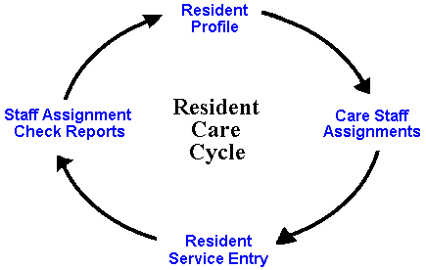

Health Leap was designed using a database management program. The program is Microsoft Windows based and very user friendly. This program is divided into two parts: the resident care data and all the objects such as forms and reports, which enable the user to manipulate and enter data. If the user is running Health Leap on a network, then the data part of the program resides on the server, while Health Leap is loaded onto each workstation using the software. In a standalone situation, both parts of the program are loaded onto the designated workstation. During installation, a program group (or group of icons) is created for Health Leap and Health Leap data.

PROGRAM ICONS

During Health Leap installation, the program creates two icon groups, which help manage your new program. In a networked setup, the Health Leap data program group remains on the server, while the Health Leap program group is on the designated workstations. In a standalone setup, both program groups are on the designated workstation. Double clicking on an icon carries out the instructions associated with that icon. For example, double clicking on the Health Leap icon will open Health Leap. The Health Leap data program group contains two icons, Workgroup Administrator and Compact/Repair Database. Health Leap also contains Workgroup Administrator and Compact/Repair Database in addition to the Health Leap and Health Leap Help icons.

Workgroup Administrator
This icon allows the user to join a different workgroup or create a new workgroup. Double clicking on the icon opens a dialog box, which shows the user where the resident care program’s system database is located.
Warning: Since all of your users should be in the same workgroup, this icon should only be used if the program cannot locate your system database (usually “system.mda”).

Workgroup
A workgroup is a group of users in a multi-user, networked environment who utilize the same data and the same system database.

System Database
A system database is a database file, which contains the security and system options for the resident care program. This file is usually called “system.mdw”.

Compact/Repair Database
Over time, as the user makes changes to the program, file storage can become fragmented. Compacting the program repairs the program making the database program smaller and often results in improved performance. For these reasons, it’s important to compact your program periodically. Sometimes, if there is a power failure, program crash, or the user simply turns off the computer without exiting properly; the program database can become corrupted. If the database becomes corrupted enough, the users will not bill able to access the program. Double clicking on the Compact/Repair Health Leap Data compacts and repairs the resident care data, while the Compact/Repair Resident Care compacts and repairs the data manipulation objects. (Typically, it’s the data that is most likely to become fragmented and/or corrupted.)

hEALTH lEAP
Double clicking this icon opens Health Leap. Before entering the main menu, you must supply your "NAME" and "PASSWORD;" and then click OK. Remember that your password is case sensitive; if your password is in uppercase letters, you must key it in that way.

Help
Double clicking this icon will display the Help Contents of the resident care on-line help file. Within the program, this help file is context sensitive and can be accessed by selecting the F1 key on the keyboard at any time. (Context sensitive help opens the help file to the currently selected topic.) The Health Leap help file provides an easy way to discover how different pieces of the resident care program work. Clicking on a highlighted, underlined word or phrase will jump you to that particular topic. You can use the SEARCH feature to search for a particular topic for information. The BACK button sends the user back to the last topic he/she accessed in the current help session. The History button displays a list of all topics viewed in the current help session in the order accessed. To jump back to the Help Contents, click on the Contents. You can print a topic by using the File pull down menu, or learn how to use on-line help and its features by using the help menu. Click the CLOSE button to exit help.

STARTING UP
All computers will be equipped with surge suppressors. The monitor and the CPU should be left in the ‘ON’ position at all times; power should be turned on and off from the surge suppressor switch. The Turbo feature located on the CPU should always be activated; there is never a need to disengage it. If during your use there is a network failure and computer stops responding, simply click the Ctrl, Alt, and Delete buttons simultaneously. If this fails to reboot your computer, press the Reset button on the CPU and initiate the sign-on procedure.

Move the cursor on top of the Resident Care icon and double-click. Before entering the main menu, you must supply your ‘NAME’ and ‘PASSWORD;’ and then click OK. Remember that your password is case sensitive; if your password is in uppercase letters, you must key it in that way.

When the hourglass appears, it is a sign that the computer is processing a series of instructions. Do not click the mouse or press any keys while the hourglass is running because the computer will remember these entries and attempt to execute them. The Main Menu will now appear.

MENUS
There are six menus in the resident care module. The menus contain labeled buttons that enable you to open the forms you need to enter and retrieve data. All the buttons in this program are simple to use. To use the mouse move the arrow over the button and click once. To use the keyboard, press down on the ALT key and the underlined letter on the button simultaneously.

BUTTONS
Exhibit 2: Buttons

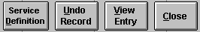

Part II

MAIN MENU
From the “Main Menu,” you can access all the other menus in Health Leap by selecting the desired menu button. In addition, you can exit the program by clicking on the EXIT HEALTH LEAP. Users may change their employee passwords using the CHANGE PASSWORD button.

Menu Options:
Resident Care Menu
Reports Menu
Communication Menu
Resident and Employee Menu
Facility Menu*

*Only users belonging to the program administrators security group can access the Facility Menu

Exhibit 3: Main Menu

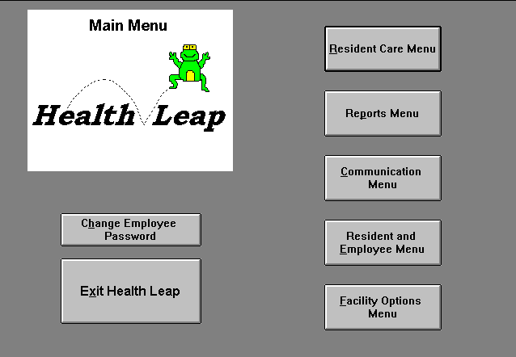

PASSWORD CHANGES
The CHANGE EMPLOYEE PASSWORD button allows an employee to change his or her old employee password to a new password. First, the employee must choose or enter his/her name. Then the employee must enter the old employee password before he/she can change the password. This protects each employee from having unauthorized users changing their passwords. Entry in the text boxes will be replaced with asterisks to conceal the password. The new password must also be verified by retyping the password in the verify box. Press OK, and the new password will be created. Press CANCEL if you decide not to change your password. Passwords should have at least five characters (letters and/or numbers) that prove easy to remember but difficult to guess. For example, use your grandmother's maiden name plus your father's birth date.
Use the Change Password feature as often as you like. If you feel someone has discovered your password, use the Change Password. The password is like a key. It is the user's responsibility to keep that key safe. The employee password is used to enter Nursing Notes and to protect Communication Messages. Without the key, the user will not have access to these capabilities.

Part III

RESIDENT CARE MENU
The forms available in this menu allow a care staff to meet their residents’ care needs in a proactive manner. The resident care staff will create resident service profiles by entering the services each resident requires. These resident profiles will in turn be utilized in creating staff assignments. The care staff will proceed to enter in the resident service they perform. Finally, the Assignment Check reports inform the care staff when services need to be added or deleted in these resident profiles, and the cycle is renewed the next shift. The “Resident Care Menu” contains the following forms:

Resident Service Entry
Resident Profile Entry
Facility Service Profile
Staff Assignments
Edit Staff Assignments
Staff Assignment Check Reports

Exhibit 4: Resident Care Menu

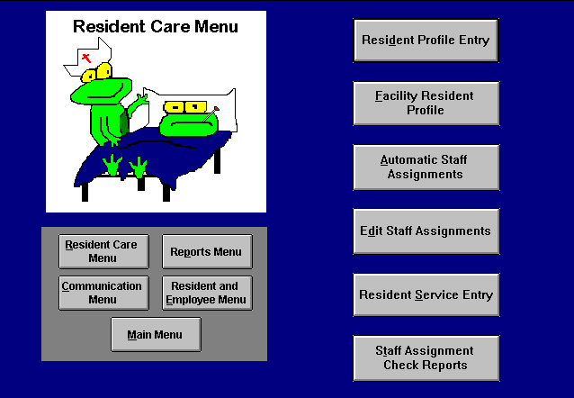

RESIDENT PROFILE ENTRY
This form allows the resident care staff to create a resident service profile by entering the services each resident requires. These resident profiles are used in creating staff assignments. The Assignment Check reports help to inform the care staff when services need to be added or deleted in these resident profiles. To enter the resident services, the user must make sure all of the following required fields are filled out:

Fields

Resident Name - the resident who needs the service performed. This list contains all residents entered through the “Resident Information” form except those who have been discharged.

Service - the service the resident needs performed. Each service has a time criteria associated with it. This time criteria is a time range measured in minutes. The user should choose the appropriate service given the resident’s needs. For example, if it typically takes a nursing aide 45 minutes to give a particular resident a Whirlpool Bath, then the aide would select the service Whirlpool Bath with a time criteria of 35 - 50, since the 45-minute bath falls between the 35 and 50-minute time intervals.

Shift - the shift the resident needs the service performed.

Weekday - the day of the week the resident needs the service performed, select Everyday if the resident needs the service on a daily basis, or PRN if the service is on an as needed basis. Services with a weekday designation of PRN will not appear on the Staff Assignments.

Start Date - Enter the beginning date for the resident’s specified service. Today’s date will be entered as the default.

End Date - Enter the last date that a resident’s specified service would be performed. The end date field is left blank if the service will be in effect for the foreseeable future.

Service Location - Enter where the service will usually be performed in this optional field. If you do not see the desired service location, you can create it by selecting "Add New/Edit" to open the “Service Locations List” form. Clicking on the ADD NEW button takes you to a blank record where you can enter a new service location. You also have the options of editing or deleting an incorrect service location. After pressing the CLOSE button to return to the “Resident Profile Entry” form, pull up the service location list again, and the location that you just added will appear on the list. Click the mouse button on that service location, and it will be selected.

Expected Outcome/Goal – The expected outcome/goal associated with the selected service should be entered automatically. The services’ default expected outcome/goals are entered and/or edited through the “Service List” form. You have the option of overriding the default choice and entering your own expected outcome/goal. This field should reflect the desired result of performing the specific service for the resident. A blank form reflects that no expected outcomes/goals have been entered previously in the “Service List” for the selected service. Click the CLOSE button to return to the Resident Profile Entry form.

Comment - enter any additional instructions or information concerning the resident service. Although this field is not required, it can be very useful. For example, you assign a resident an evening Whirlpool bath on Wednesday. The evening shift runs from 3:00 p.m. to 11:00 p.m.; however, you knows the resident retires for bed every night at 8 p.m. You could then enter in the comment field “Please bathe by 7:30. Resident’s bedtime: 8 p.m.”

Specific Week - appears only when you select the specify week option from the ‘Assign’ box. You select this option when you wish to assign services on a monthly basis instead of a weekly basis. You can select service a service for the First, Second, Third, or Fourth week during the month.

Once you have completed the aforementioned fields, you will need to select the desired resident in the resident name field. You can utilize the scroll bar on the right side of this field to find the correct resident. Next, choose the appropriate service to assign to the resident’s profile, the shift the resident needs the service performed, and the appropriate weekday for the service (Sunday - Saturday, Everyday, or PRN). The start and end date fields should reflect the date period over which the specified service will be in effect. The end date field is left blank if the service will be in effect for the foreseeable future. Optional fields include the following: service location, expected outcome/goal, and comment. The comment field will also be included on the Staff Assignments. You can choose only one shift and weekday option at a time. If the resident needs the service on different shifts or days or multiple times on the same shift or day, a resident service profile record needs to be created for each time and shift. An example would be a resident who receives her medications twice everyday during the day shift.

For the most part, you will enter records in the “Resident Service Profile” on a weekly basis. Nevertheless, sometimes a resident may receive a specific service only once or twice a month. For example, your facility may weigh every resident once a month. In these cases, the user should select the ‘specify week’ option in the assign box at the top of the form. Selecting this option opens the ‘Specific Week’ field which should be filled out in addition to the other required fields. The user can then choose which week during the month (First, Second, Third, or Fourth) that service needs to be performed. If you fail to enter a specific week, then the resident service will be assigned every week. When assigning services to a resident profile on a weekly basis, the ‘every week’ option should be selected in the assign box.

Buttons
Once the required fields are completed, you can choose from several button options on the right side of the form. Using these buttons allows the user to view the resident service plans and profiles, add services to a residents profile, undo a profile record, and close the “Resident Profile” form. Once the user enters the appropriate information in the entry fields, clicking on the PROFILE ADD button adds this record to the resident profile and then creates a new profile record. You have the option of carrying over any of your field selections to the new profile record by marking the selection boxes located to the left of each field. For example, if the user marks the selection boxes for the resident name, service, and comment fields, these selections will be retained intact after PROFILE ADD is pressed. Users should utilize these selection boxes to save themselves time.

Often you want to review a resident’s service profile to ensure that the profile is accurate and up-to-date. Once you select a resident’s name, clicking the PROFILE VIEW button opens the “Resident Profile View” form, which lists the resident’s entire profile of services. Similarly, pressing the SERVICE PLAN button opens the “Resident Service Plan” form for the selected resident, which lists a more detailed version of the resident’s service profile. The UNDO RECORD button erases the your entry in the current profile record. This button is helpful when you enter a record by mistake. If you do not understand what is meant by a particular service, clicking the SERVICE DEFINITION button will bring up the selected services definition. Selecting the CLOSE button closes the “Resident Profile Entry” form and returns the user to the “Resident Care Menu.”
Exhibit 5: Resident Profile Entry

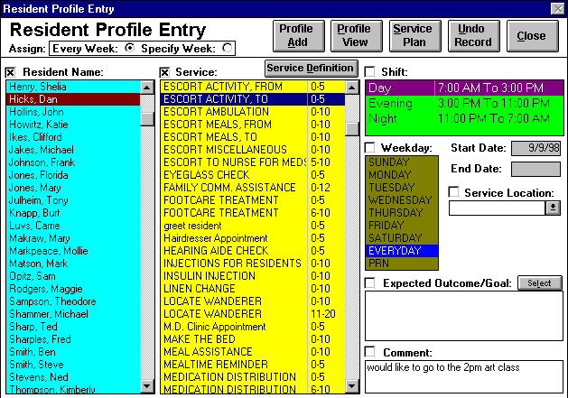

Resident Profile View
Once you select a resident’s name in the “Resident Profile Entry” form, clicking the PROFILE VIEW button opens the “Resident Profile View” form, which lists the resident’s current profile of services. This form includes the current profile services plus the profile services whose start dates are in the future. Pressing on the SHOW ALL button will show all profile services including those whose end dates occur before today’s date. The average daily time and total weekly time calculate the amount of staff time required for the residents profile services on a daily and weekly basis respectively. The start date, end date, weekday, shift, specific week, and comment fields can all be edited through this form. If the resident no longer needs a particular service, enter the last date the service needs to be performed in the end date field. Conversely, if a record was entered erroneously, you can delete the unnecessary record(s) through this form. Simply select the appropriate record selector(s) and press the delete key from the keyboard. If you wish to print the selected residents current resident service profile, click the PRINT button. If the resident needs services added to his/her profile, then select the CLOSE button and add the desired services through the “Resident Profile Entry” form. The “Resident Profile View” form allows the use of the Sort Options Menu.

Exhibit 6: Resident Profile View

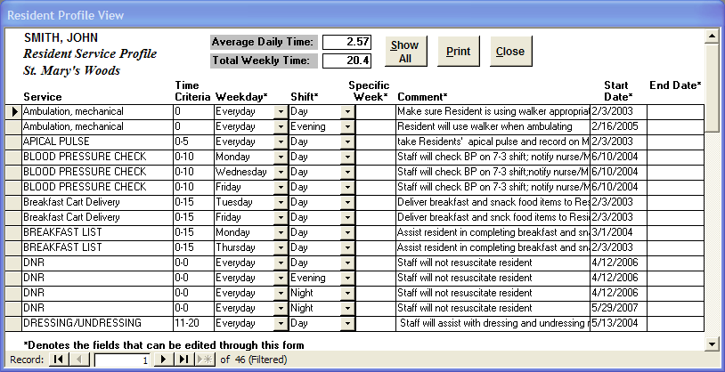

Resident Service Plan
Once you select a resident’s name in the “Resident Profile Entry” form, clicking the SERVICE PLAN button opens the “Resident Service Plan” form, which lists a detailed version of the resident’s service profile. This form includes the current profile services plus the profile services whose start dates are in the future. Pressing on the SHOW ALL button will show all profile services including those whose end dates are before today’s date. The average daily time and total weekly time calculate the amount of staff time required for the residents profile services on a daily and weekly basis respectively. The start date, end date, service comments, weekday, shift, service location, specific week, and expected outcome/goals fields can all be edited through this form. The service provider field reflects the staff type associated with profile service as defined through the “Services Assigned By Staff Type” form.

If the resident no longer needs a particular service, enter the last date the service needs to be performed in the end date field. Conversely, if a record was entered erroneously, you can delete the unnecessary record(s) through this form. Simply select the appropriate record selector(s) and press the delete key from the keyboard. After clicking the PRINT button a message box appears giving you the option of printing the “Resident Service Plan” with or without the signature section. If the resident needs services added to his/her profile, then select the CLOSE button and add the desired services through the “Resident Profile Entry” form. The “Resident Service Plan” form allows the use of the Sort Options Menu.

Exhibit 7: Resident Service Plan

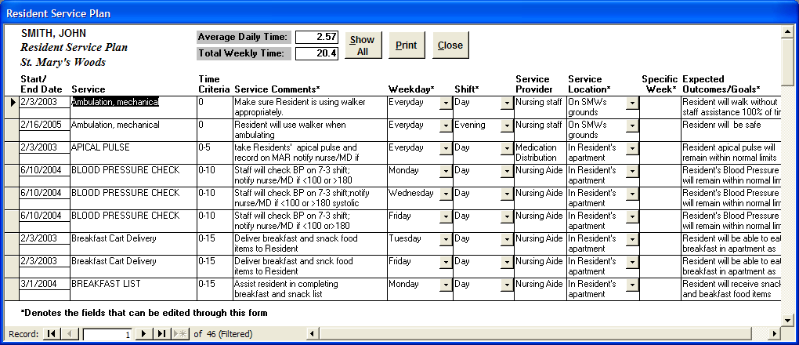

FACILITY RESIDENT PROFILE
This form includes the current profile services plus those services whose start dates are in the future of all the residents entered through the “Resident Information” form except those who have been discharged. Pressing on the SHOW ALL button will show all profile services including those whose end dates occur before today’s date. Instead of reviewing a single resident’s profile as in the “Resident Profile View” form, the “Facility Resident Profile” form allows you an overview of your entire facility. Through the filter options and Advanced Option menu, you are able to filter and sort your profile records in a myriad of ways. This form contains the following fields:

Fields
Resident Name - the resident who needs the service performed.

Service - the service the resident needs performed.

Time Criteria - each service has a time criteria associated with it. This time criteria is a time range measured in minutes.

Shift - the shift the resident needs the service performed. Editable.

Weekday - the day of the week the resident needs the service performed or ‘Everyday’ if the resident needs the service on a daily basis. Editable.

Specific Week - if this field is blank the resident will receive the specified service on a weekly basis. If this field contains a number (1-4), the number refers to the week in a month the service will be performed. Editable.

Unit Designation - the specific wing or unit of a facility where the resident lives.

Comment - enter any additional instructions or information concerning the resident service. This field is also located at the top of the form and lists the comment of whichever profile record is current. Editable.

Start Date - the beginning date for the resident’s specified service. Editable.

End Date - the last date that a residents specified service would be performed. The end date field is left blank if the service will be in effect for the foreseeable future. Editable.

Filter Options
The filter options provide an efficient way to extract specific information from the facility resident profiles. To initiate a filter, click on the option button () to the left of the desired filter selection to open a list of choices. (For example, choosing the individual service option opens a list of all your services). Next, select the desired item from the list. Then you can either choose another filter selection to refine your list even more, or process the records with the current selection by clicking the FILTER button. For example, suppose you wanted to know which residents receive Whirlpool Baths on the Day shift. Simply click the individual service option button and choose ‘Whirlpool Bath’ from the list. Next, select ‘Day’ from the shift filter list. Pressing the FILTER button reduces the profile records to Day shift Whirlpool Baths. Click the UNFILTER button to show all the profile records again. The following filters are located in the upper left-hand side of the form:

Resident - list contains all residents entered through the “Resident Information” form except those who have been discharged.

Weekday - the days of the week (Sunday-Saturday) including the ‘Everyday’ option.

Shift - all the facility shifts as defined in the “Software Options” form.

Unit Designation - all specific units or wings in a facility as defined in the “Software Options” form.

Individual Service - all facility services as entered in the “Service List” form.

Multiple Services - allows you to filter by multiple services. Choosing the ‘Add New/Edit’ item from this list opens the “Multiple Filter Service Selection” form, which allows you to define or edit multiple service filters by determining what services comprise each filter.

You can print the “Facility Resident Profile” by clicking the PRINT button or close it by clicking the CLOSE button. This form allows the use of the Sort Options Menu.

Exhibit 8: Facility Resident Profile

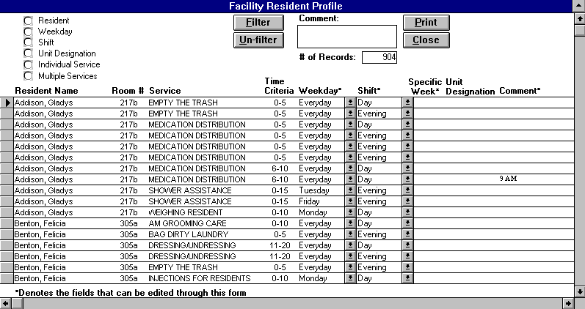

MULTIPLE SERVICE FILTER SELECTION

Accessed only through the “Facility Resident Profile” and “Nursing Assignments” forms, this form allows you to define and/or edit multiple service filters. In a multiple service filter, you select which services you want to comprise a given filter. For example, a multiple service filter called ‘Bathing’ might contain the services ‘Whirlpool Bath’ and ‘Shower Assistance.’

To create a new multiple service filter, first click the ADD NEW button. Next, type a descriptive name for your filter in the filter name field. On the left side of the form is a list box of services to choose from in creating your filter. On the right side of the screen is a list box containing the services, which define your multiple service filter. This list box is now blank, because you have not yet added any new services to the filter. You can add services to your filter in either of two ways. One technique is simply to double click on the desired service. Another method is to single click the desired service and click the ADD button. Removing services from a filter works very similarly. You can either double click the unwanted service in the filter list or select the service and click the REMOVE button.

Furthermore, you have the ability to edit a previously created multiple service filter. Select the appropriate filter from the ‘Select service filter:’ list to make that filter current. Then add and/or remove services from the filter as you see fit. You can also edit the filter’s name in the filter name field. Clicking the DELETE button deletes the current multiple service filter completely. Pushing the PRINT button prints out a list of all the multiple service filters and their services. Selecting the CLOSE button exits the form and returns you to the form you were in.

Exhibit 9: Multiple Service Filter Selection

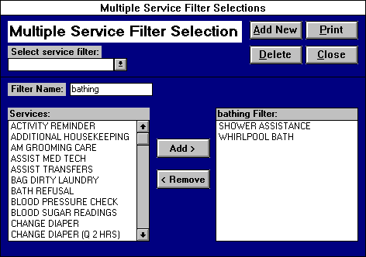

AUTOMATIC STAFF ASSIGNMENTS
The “Automatic Staff Assignments” form allows the care staff to quickly assign resident services and print out staff assignment sheets. These assignments are created from the resident service needs entered in through the “Resident Service Profile” form. Residents that are LOA during the specified shift and date are not assigned. To maintain care quality and promote staff efficiency, the computer follows two rules when creating these automatic assignments. First, the computer assigns all of a resident’s services of a given staff type to the same employee so as to ensure continuity of care and maximum efficiency. Second, the computer assigns resident services to employees in room number order so as to limit the distance between the employees assigned residents to the extent possible.
Exhibit 10: Automatic Staff Assignments

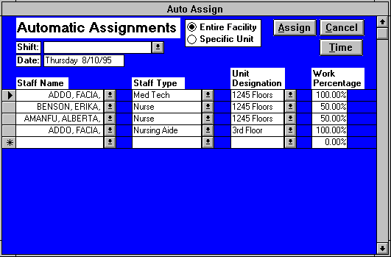

You can make assignments for either the entire facility or a specific unit. If you choose the specific unit option (top, center of form), then the specific unit field will appear and the desired unit designation should be selected. The user has the option to assign staff to any unit designation, which is a subset of the selected unit designation. For example, a facility has created three unit designations: first floor, second floor, and assisted living. First floor contains all the resident rooms on the first floor, while the second floor designation contains all second floor rooms. The assisted living unit designation contains all the rooms on both the first and second floors. If the user selects assisted living as the specific unit designation, the user can now assign staff not only to assisted living, but the first and second floor unit designations as well. The user will not be allowed to assign staff to unit designations, which contain room(s) not within the specified unit designation. The following fields need to be completed before you can click the ASSIGN button to create your staff assignments:

Shift - the shift for which you wish to create assignments. List from “Software Options.”

Date - today’s date entered by default, but you can edit this field to reflect the date for your assignments

Employee Name - each care staff member selected from the list of current employees for the purpose of assigning resident services. A staff person may be entered multiple times if he/she is working on multiple units or performing multiple staff types. For example, if a shift is short staffed a nurse may have to assume the duties of both a nurse and a nursing aide. You would then enter the nurse in the form twice, once as a nurse and once as an aide. The employee list is entered through “Employee Information.”

Staff Type - the appropriate staff type for each care provider. In the “Services Assigned By Staff Type” form, the care coordinator assigns the appropriate services to each staff type. For example, the care coordinator assigns the service Medication Distribution to the staff type Med Tech. Therefore, the computer will assign all the resident Medication Distribution services to the employees you have designated as a Med Tech. The Staff Type list is defined in “Software Options.”

Unit Designation - the specific unit the employee will work on. If you wish to assign the staff person to multiple units, then you need to enter the employee for each different unit. The Unit Designation list is defined in “Software Options.”

Work Percentage - the percentage of work you want an employee to do given the specified staff type and unit designation. For example, suppose you want to assign an employee half the Med Tech services in your Assisted Living unit. You would select the employee’s name; choose the Med Tech staff type and the Assisted Living unit designation. Then you would designate the employee’s work percentage as 50%. You can assign any combination of work percentages to your employees, as long as they add up to 100% for a given staff type and unit designation. Clicking the Calc Work % button automatically sets the optimal work percentages for your assigned staff.

Clicking the Calc Work % button automatically sets the optimal work percentages for your assigned staff. When employees work multiple units and/or staff types, manually calculating work percentages becomes arduous. The Calc Work % button solves this problem by automatically calculating the work percentages for the assigned staff, which will result in the most even distribution of assignments possible. This does not mean necessarily that each employee will be assigned the same amount of time since employees can only be assigned work for their selected staff types and unit designations. Using the Calc Work % button is not required to make assignments and the user may override any work percentages assigned.

PROJECTED STAFF TIME
Often, when you make staff assignments you wish to view the total amount of work time will be assigned to each employee based on the work percentages you have allocated. After entering the desired shift and date you can click on the PROJECTED TIME button to open the “Projected Staff Time” form. This form reveals the total amount of the service time* in hours.minutes that each employee has been assigned based on your specified work percentages. This form can be left open and will update the staff service times as you change the employee work percentages. Clicking the CLOSE button will close this form.

*This is only projected assignment time since the computer does not split up a resident’s services for a given staff type between employees. Nevertheless, projected time is usually a good approximation of the employee assignment times.

Exhibit 11: Projected Staff Time

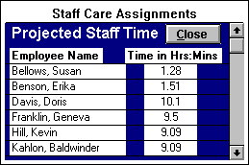

ASSIGNMENT ACUITY BY UNIT
Often, it’s important to know how much service time each unit designation and staff type requires, so the user can assign the appropriate number of staff to perform the necessary resident care services. After you have entered the correct shift and date and specified whether you are assigning services for the entire facility or a specific unit, you can click on the STAFF TYPE TIME button to open the “Assignment Acuity” form. This form details the total amount of the service time in hours.minutes that each unit designation and staff type requires to meet the assigned resident needs. (Note: An unspecified staff type refers to services that the program administrator has not assigned to staff types in the “Services Assigned By Staff Types” form.) Clicking the CLOSE button, will exit the form.

Exhibit 12: Assignment Acuity By Unit

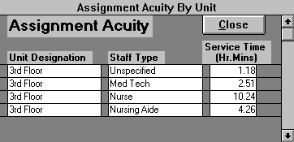

When you have completed entering your required fields, click the ASSIGN button. This action creates your assignments and opens the “Staff Care Assignments” for a detailed view. If you do not wish to make staff assignments, click the CANCEL button at any time to return to the “Resident Care Menu.”

STAFF CARE ASSIGNMENTS
This form lists the resident care services and the employees you have assigned to perform them for a specific shift, date, and if selected, unit designation. The form provides the person creating shift assignments the flexibility to edit the automatic staff assignments before printing. If you wished to assign a different employee to a particular service(s), first you choose the desired employee in the ‘Employee assigned:’ list. Then, you just click in the person assigned field of each record you want assigned to the selected employee. Each change in the person assigned to a service updates the subform located on the upper left side of the form. This subform details each assigned employee, his/her projected service time, and the number of services assigned. You can view all the assignment records by utilizing the scroll bars on the right side of the form. These assignment records are composed of the following fields:

Fields
Room # - the room where the resident currently resides.

Resident Name - name of resident requiring the service.

Service - the service the resident needs performed.

Time Criteria - time criteria associated with each service. This time criteria is a time range measured in minutes.

Person Assigned - the employee assigned to perform the service. If no employee has been assigned, this field will read ‘Unassigned.’

Comment - located at the top of the form and lists the comment of whichever assignment record is current. If the assignment creator has any additional instructions concerning a particular resident service, he/she can edit or add this information in the comment field. This comment will print out on the assigned employee’s assignment sheet. Comments added or changed through this form are only for the current assignments. Permanent changes to service comments must be made through the “Resident Service Profile” form.

Filter Options
The filter options provide an efficient way to view specific information about a given staff assignment. To initiate a filter, click on the option button () to the left of the desired filter selection to open a list of choices. (For example, choosing the ‘individual service’ option opens a list of all your services). Next, select the desired item from the list. Then you can either choose another filter selection to refine your list even more, or process the records with the current selection by clicking the FILTER button. Pressing the FILTER button reduces the assignment records to whatever filter options you have selected. Click the UNFILTER button to show all the assignment records again. The following filters are located on the right-hand side of the form:

Employee Filter - contains the employees who have been assigned resident service(s).

Unassigned Filter - mutually exclusive from the employee filter since it filters out all those records, which were not assigned to an employee.

Resident Filter - contains all the residents listed in this form.

Individual Service Filter - this list contains all services listed in this form.

Multiple Services Filter - allows you to filter by multiple services. Choosing the ‘Add New/Edit’ item from this list opens the “Multiple Filter Service Selection” form, which allows you to define or edit multiple service filters by determining what services are associated with a given filter type.

Exhibit 13: Staff Care Assignments

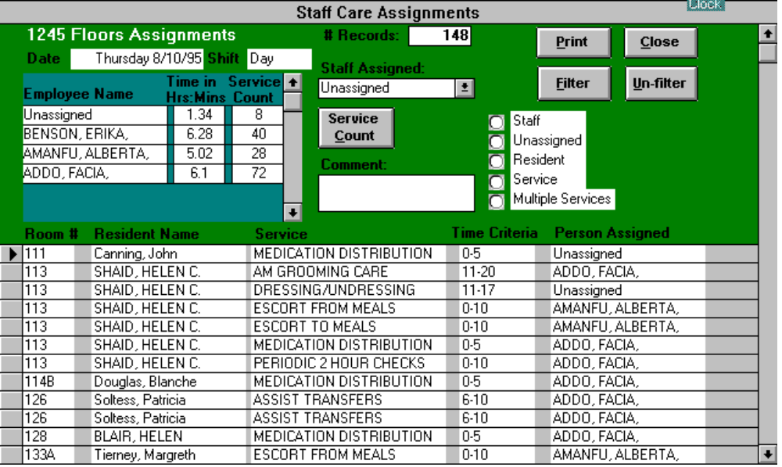

When you are ready to print the staff assignments, click the PRINT button, which opens the “Assignment Print Selection” form. At the top of the form is the ‘Print Options’ box. You can choose to print out your “Staff Assignment Sheets” and/or the “Assignment Master” report. The Staff Assignment Sheets print out an assignment sheet for each care provider designated on the “Care Staff Assignment” form. The care staff should carry these assignment sheets with them as they perform resident services so they can mark off and/or add resident services as they complete them. The Assignment Master report is a condensed version of the assignment sheets. The care supervisor uses the “Assignment Master” report to keep track of all the resident services and the care staff assigned to these services.

You also can select an option from the selection options box. Although you will usually will select ‘All,’ sometimes you need only to print some of the assignments. For example, one of your employees loses his assignment sheet. You would choose click on ‘Individual Employee’ and choose the appropriate care provider from the employee list that appears. Clicking the PRINT button then will print out only the selected employee’s assignment sheet. Click the CLOSE button to return to the “Staff Care Assignments” form. Select one of the following print options:

All - (default) all staff assignment sheets. If you only created staff assignments for a specific unit designation, then only the assignments for the designated unit will print.

Staff Type - staff assignments of the selected staff type. The staff type list contains all the staff types represented in the current assignments.

Unit designation -staff assignments for the designated unit. The unit designation list contains all the unit designations represented in the current assignments.

Staff Type and Unit Designation - assignments for care staff of the selected type who you assigned to perform resident services on the selected unit(s).

Service - assignments for a selected service. You can only choose services from the current assignments.

Individual Employee - only the assignments for the designated employee. Employee list contains all the employees assigned to resident services in the current assignments.

Unassigned - all the unassigned resident services.

Sometimes, the care supervisor wishes to review the count of each service type assigned to each member of the care staff. To view these service type counts click the SERVICE COUNT button to open the “Assignment Service Count” form. At the top of this form is the ‘Select desired service’ list box, which enables you to view the service type counts for a selected service. Press the CLOSE button to return to the “Staff Care Assignments” form. Click the CLOSE button to exit “Staff Care Assignments” and return to the “Resident Care Menu.” The “Staff Care Assignments” form allows the use of the Sort Options Menu.
Exhibit 14: Assignment Print Selection

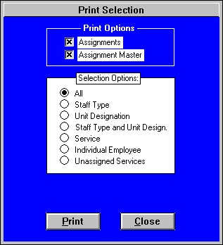

Exhibit 15: Assignment Service Count

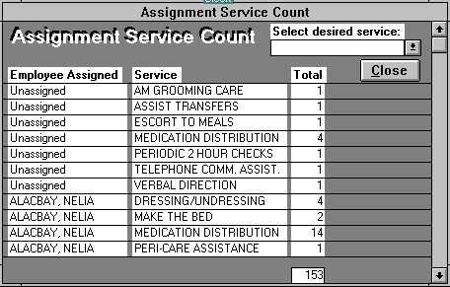

EDIT STAFF ASSIGNMENTS
Every once in a while, you need to bring up your staff assignments again for editing or reprinting. For example, a care staff member calls in sick after the assignments have been made; an aide loses his assignment sheet, etc. The program saves the most recent week of assignments, so you can view staff assignments for any date in the last seven days. You can open assignments for either the entire facility or a specific unit. If you choose the specific unit option (top, center of form), then the specific unit field will appear and the desired unit designation should be selected. Next, choose the appropriate shift and date. Clicking the EDIT button will open the “Staff Care Assignments” form containing the desired assignment records.

Exhibit 16: Edit Staff Assignments

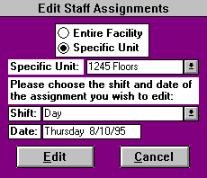

RESIDENT SERVICE ENTRY

This form allows the care staff to track easily and efficiently all services provided to residents. To enter the resident services performed, the care provider must make sure all of the following required fields are filled out:

Fields
Employee Name - the name of the care provider who performed the service. This field list contains the names of all the currently active employees as entered in the “Employee Information” form.

Resident Name - the resident for whom the care provider performed the service. This list contains all the residents currently in the building as entered through the “Resident Information” form.

Service - the service performed by the care provider. Each service has a time criteria associated with it. This time criteria is a time range measured in minutes. The care provider should choose the appropriate service, which falls within the time range. For example, if a nursing aide gave a resident a 25 minute Whirlpool Bath, then the aide would select the service Whirlpool Bath with a time criteria of 20 - 30, since the 25 minute bath falls between the 20 and 30 minute time intervals.

Shift - the shift the resident service was provided.

Date - the date the resident service was provided.

Current Entry – shows all the resident services entered by the employee during the current entry session. Review this list as you enter records to check for entry errors. You can double click in the resident’s name field to delete an erroneous service record. To see a selected employee’s entire service entry for the specified date and shift open the “Current Service Entry” form by clicking the VIEW ENTRY button.

*Consult your care coordinator for instructions if the service time exceeds the largest time criteria.

When entering resident services, the care provider should first check that correct shift and date are entered in the appropriate fields located at the top of the form. If either of these fields is incorrect, the user should edit accordingly.

Now, the care provider selects his/her name from the employee name field. You can select the appropriate name by clicking the underlined arrow on the right side of the boxes and then using the up and down arrows to scroll through the alphabetized list of employees. As this list can be very long, there is a useful short cut: Click the underlined arrow on the right side of the box and begin typing the name you are looking for (last name, first name). Once your search locates the appropriate person, either click the person’s name from the list or press enter. Next, the care provider selects the resident for whom he/she provided a service. Then, the care provider should choose the service performed.

Buttons
Using the ASSIGN ENTRY, RESIDENT LOCK and SERVICE LOCK buttons are particularly effective ways to enter large numbers of services quickly and efficiently. Once an employee selects their name in the employee name field, clicking the ASSIGN ENTRY button opens the “Employee Assignment Entry” form. This form will detail every service the employee has been assigned for the given date and shift on the “Service Entry” form that has not yet been entered as completed. The program automatically will enter all resident services the employee marks as having done (Done boxes marked with an 'X') when this form is closed. If the service completed required a different time criteria than the one listed, the user has the option of selecting the appropriate time criteria from the drop down box. Clicking in the desired field and choosing either sort ascending or descending from the Sort Options List in the upper left-hand corner of the screen will sort the form's fields. Unassigned services that the user completes should be entered with the regular method through the Service Entry form using the LOCK buttons.

Clicking the RESIDENT LOCK button “locks” the previously selected resident and employee names for service entry. Now you simply click on the appropriate services you have performed for the selected resident. The computer creates a service entry record with the employee and resident names for each service selected. If you select a different resident, then clicking on the desired services will create service entry records for the newly chosen resident. Clicking the RESIDENT LOCK button a second time “unlocks” the resident lock. The SERVICE LOCK button works similarly except the service is “locked” instead of the resident. After initiating the service lock, you can select all the residents for whom you performed the same service. When using the service lock, be careful of enter residents with the correct service but wrong time criteria. Clicking the SERVICE LOCK button a second time “unlocks” the service lock.

The current user presses the RECORDING COMPLETE button when he/she is finished entering all the completed resident services. This button causes the form to go to a new resident service record, awaiting the entry of the next care provider.

If the care provider is unsure of what is meant by a particular service, clicking the SERVICE DEFINITION button will bring up the selected service’s definition. The service definition will change to reflect whichever service the user chooses. Clicking on the SERVICE DEFINITION button again closes the service definition box. Often you want to review your resident service entry to ensure that your have not entered your services incorrectly. Clicking the ENTRY VIEW button opens the “Current Service Entry” form, which lists all the resident services you have entered during the current shift and date on the computer. The UNDO RECORD button erases your entry in the current entry record. This button is helpful when you enter a record by mistake. Selecting the CLOSE button closes the “Resident Service Entry” form and returns the user to the Resident Care Menu.

Trying to enter all services completed at once creates a backup at the computer, especially if this is done at the end of the shift. The nurse should encourage her staff to enter their data in at least twice a shift, and more times if possible. Furthermore, the nurse should remind her staff that they can only enter the services that they have already completed, not the ones they intend to do. The nurse should also ensure that all the nursing staff carry with them their staff assignment sheets at all times. After a staff member completes an assignment, that assignment should be check off on the sheet. Any assignment the aide or nurse completes that does not appear on the sheet should be written down immediately on the assignment sheet. Do not allow staff members to try to remember what they have done during the shift at the computer. This technique creates logjams at the computer and results in inaccurate and understated resident services. The Nursing staff at your facility works hard, they should get credit for it.

Exhibit 17: Resident Service Entry

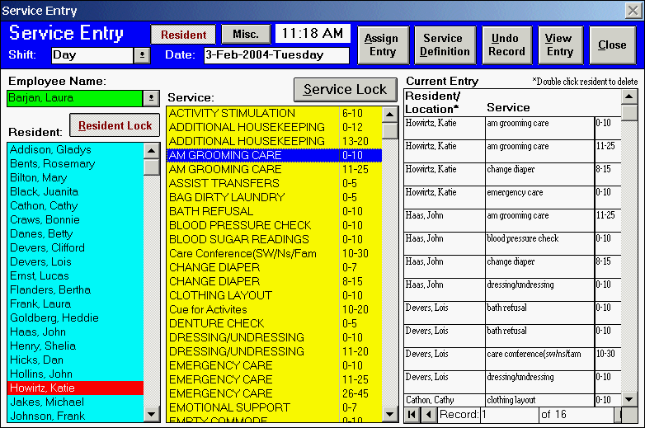

Current Service Entry
Often you want to review your resident service entry to ensure that your have not entered your services incorrectly. Clicking the VIEW ENTRY button on the “Resident Service Entry” form opens the “Current Service Entry” form, which lists the all the resident services, entered by the specified employee during the specified shift and date. If you find any incorrect entry(s), you can delete the unnecessary record(s) through this form. Simply select the appropriate record selector(s) (small, gray, rectangular box to the left of each record) and press either the delete key from the keyboard or the DELETE button. If you neglected to enter some resident services, then select the CLOSE button and add the desired services through the “Resident Service Entry” form. This form allows the use of the Sort Options Menu.

Employee Assignment Entry

The most efficient way to enter your assigned resident services is to utilize the “Employee Assignment Entry” form. Once an employee selects their name in the employee name field, clicking the ASSIGN ENTRY button opens this form. This form will detail every service the employee has been assigned for the given date and shift on the “Service Entry” form that has not yet been entered as completed. The program automatically will enter all resident services the employee marks as having done (Done boxes marked with an 'X') when this form is closed. The next time the employee opens this form only those services still marked uncompleted will appear. If the service completed required a different time criteria than the one listed, the user has the option of selecting the appropriate time criteria from the drop down box. Unassigned services that the user completes should be entered with the regular method through the Service Entry form using the LOCK buttons. This form allows the use of the Sort Options Menu.

STAFF ASSIGNMENT CHECK REPORTS

The purpose of these forms is to provide the care supervisor with reports that identify what transpired in resident care during the current shift. These reports should be reviewed every shift. Specifically, this form allows you to select for viewing and/or printing the following three reports “Uncompleted Services,” “Services Not in Profile,” and “Employee Completed Services.” These reports will identify the resident services in the resident profile left uncompleted by the care staff, the services completed that are not in the profile, and the number of services and service time each care staff member logged during the shift. From this information, the care supervisor will update the necessary resident profiles.

For these reports, you can choose either the entire facility or a specific unit. If you choose the ‘specific unit’ option (top, center of form), then the specific unit field will appear and the desired unit designation should be selected. Next, select the appropriate shift and date. The program saves the most recent week of assignments, so you can view assignment check reports for any date in this week period. For example, assignments made for the Monday day shift on Feb. 2 will not be replaced until assignments are made for Monday day shift on Feb. 9. At the bottom of the form, the Reports Option box offers the opportunity to select which of the reports you wish to view or print. Clicking the VIEW button allows the selected reports to be viewed on the screen, while the PRINT button prints the reports. The CANCEL button closes this form and returns the user to the Resident Care Menu.

Exhibit 18: Staff Assignment Check Reports

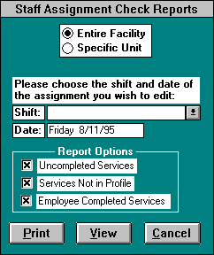

UNCOMPLETED SERVICES

This report identifies for the care supervisor all the services, which are currently in the resident profiles for the specified date and shift but were not completed by a care staff member. Services show up on this report for the following reasons. One, the assigned employee did not complete the service because the resident no longer requires it. If the care supervisor concurs with this assessment, then he/she will delete the unnecessary service from the resident profile utilizing either the “Facility Resident Profile” or “Resident Profile View” forms. Two, the employee may have completed the service, but either neglected to enter the resident service in the “Resident Service Entry” form or inputted the service incorrectly. In the either case, the employee should enter the record(s) into the “Resident Service Entry” form. In the latter case, the care supervisor should utilize the “Service Entry Review” form in the Reports Menu to identify and delete the mistaken entry. Three, the employee did not complete his/her assignments or the service was mistakenly unassigned. In these cases, the care supervisor should arrange for these uncompleted services to be performed. If an employee other than the assigned one completes a resident profile service, that resident and service will not show up on this form.

The “Uncompleted Services” report lists the employee assigned, resident name, service, and the service count. Any unassigned services are noted in the employee assigned field. The service count field adds up the number of uncompleted services for a specific resident and service. For example, a resident receives three Medication Distribution services on Thursday’s day shift. The assigned employee only completes and inputs one of these Medication Distribution services. The service count for Medication Distribution for this resident would be 2, since two of the Medication Distributions were not performed. If multiple employees are assigned to perform the same service for the same resident and the service is uncompleted, then all the assigned employees show up on this form, and the service count for each reflects the total number of uncompleted services. Clicking the PRINT and CLOSE will print and close the form respectively. The “Uncompleted Services” report allows the use of the Sort Options Menu.

Exhibit 19: Uncompleted Services
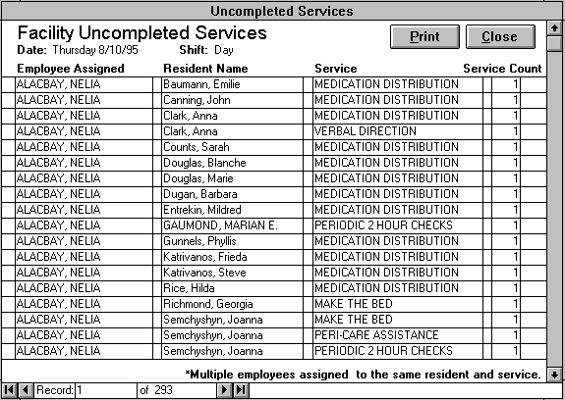

SERVICES NOT IN PROFILE

This report is the opposite of the “Uncompleted Services” report. Because resident care needs change, this report enables the care supervisor to identify all resident services which your care staff inputted for the specified date and shift but that are not in the resident profile or at a lesser frequency. The care supervisor should review these services and consult with their care staff to determine which services should be added to the individual resident profiles through the “Resident Profile Entry” form.

The “Services Not in Profile” report lists the employee assigned, resident name, service, and the service count. The service count field is the difference between the number of services entered by the care staff and the number of services currently in the profile for a specific resident and service For example, a resident receives one Blood Sugar Reading on Tuesday’s day shift. An employee performs this service for the resident three times during the shift. The service count for Blood Pressure Check for this resident would be 2, since two more Blood Pressure Checks were performed then were recorded in the resident profile. If multiple employees complete the same service for the same resident and the service is “not in profile,” then all these employees show up on this form, and the service count for each reflects the total number of services not profiled. Clicking the PRINT and CLOSE will print and close the form respectively. The “Services Not in Profile” allows the use of the Sort Options Menu.

Exhibit 20: Services Not in Profile

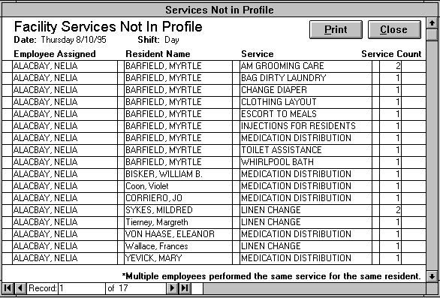

EMPLOYEE SERVICE COMPLETION
This report provides the care supervisor a complete breakdown of the resident care services each member of the care staff completed during a specified shift and date. The top part of the report provides the following information fields:

Fields
Total Time - the total amount of time in hour.minutes that the care staff spent providing resident services during the specified shift and date. This is based on the time weights assigned to each service in the “Service List” form.

Total Count - the total number of resident services provided during the selected shift and date.

Employee - all employees who inputted at least one service for the specific shift and date. If the form is viewed for a specific unit designation, it would only list employees who performed a service(s) on the designated unit. Service count and time are broken down by employee and unit designation.

Unit Designation - the specific unit where the residents receiving the care services live.

Service Count - the number of services the employee completed for the specified unit designation.

Time - the amount of time in hour.minutes that the services took to complete. Based on the services entered by the employee and the service time weights associated with those services.

The bottom half of the report provides the service detail of whichever employee/unit designation record you select. Therefore, you can view the individual services, which the selected employee provided on the specified unit designation. The count field shows the number of times an employee provided a given service, while the time field totals in hours.minutes the amount of time the service(s) should have taken. The care supervisor should utilize this form to ensure that the care staff is recording their resident services properly.

Clicking the PRINT TOTALS button will print only the top half of the report, the employee service completion totals. To print these totals and the individual service detail, click the PRINT DETAIL button. Pressing the CLOSE button will close this report. This report allows the use of the Sort Options Menu.
Exhibit 21: Employee Service Completion

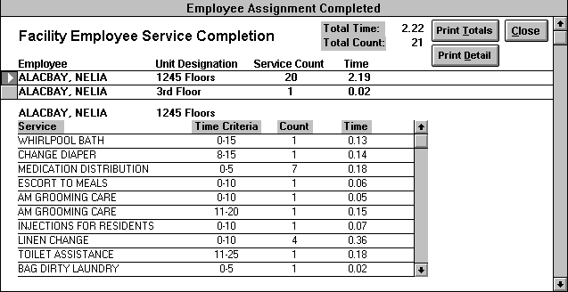

Resident Tracking Items

This form allows the user either to enter for their residents any additional important info not covered by the service profiles and service entry or create reports based on this entered data. You choose one of the following options:

Resident Tracking Entry - selecting this option opens the “Resident Tracking Entry” form. Through this form the user enters for each resident any additional important information such as weight, blood pressure, food consumption, mental acuity, etc…that your facility deems important enough to track.

Resident Tracking: Report Creation - selecting this option opens the “Resident Tracking Items: Report Creation” form. This report allows the user to create five different reports over an user defined date range based on the data entered in the “Resident Tracking Entry” form.

Exhibit 22: Resident Tracking Options

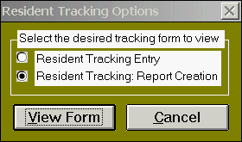

Resident Tracking Entry

You utilize this form to enter any additional resident information you wish to track, which your facility deems worthwhile. For example, you can track the weight of your residents through this form. You could enter a resident’s weight at specified intervals through this form, and then create a report through the “Resident Tracking Items: Report Creation” form which would show the resident’s weight change over a specified date range. You capture this additional information by creating tracking items in the “Resident Tracking Items” form on the Facility Options Menu.” To enter a new resident tracking item entry simply click the ADD NEW button to go to a new record. You have the option of carrying over any of your field selections to the new entry record by marking the selection boxes located to the left of each field. For example, if the user marks the selection boxes for the tracking item and employee name, these selections will be retained intact after ADD NEW is pressed. Users should utilize these selection boxes to save themselves time.

Fields
Tracking Item – select the tracking item from the pull down list for which you wish to enter resident data. Tracking Items are any additional data that your facility deems important enough to record about its residents in order to provide better care. Examples of tracking items are resident weight, falls, blood pressure, food consumption, mental acuity, etc… Tracking items are created in the “Tracking Items” form on the Facility Options Menu.

Resident Name – choose the name of the resident you are entering information about.

Employee Name – select the employee’s name that is recording the information.

Text Value – if the tracking item requires a text value entry you would enter it in this field. For example, for the tracking item food consumption, you could select the appropriate choice from a list of none, partial, most, and all. Some tracking items can require both a text value and number value.

Number Value - if the tracking item requires a numerical value entry you would enter it in this field. For example, for the tracking item resident weight, you would enter how much the resident weighs in this field on the entry date.

Entry Date – enter the date, which the tracking item information is gathered.

Comments – utilize this field to enter any add ional pertinent information

Current Entry – shows all the resident tracking item entries put in by the employee during the current entry session. Review this list as you enter records to check for entry errors. You can double click in the resident’s name field to delete an erroneous record.

Clicking on the DELETE button will delete the current resident tracking item record entry. Press the CLOSE button to return to the “Resident Care Menu.”

Exhibit 23: Resident Tracking Items Entry

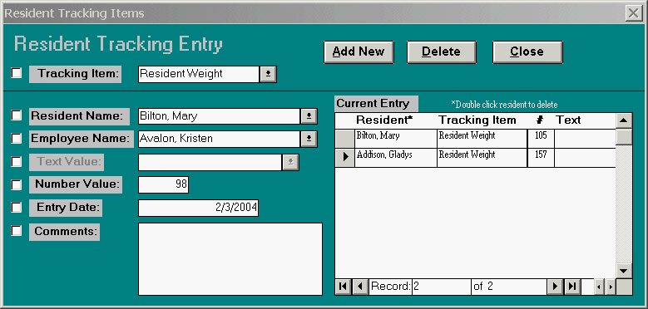

Resident Tracking Items: Report Creation

This report allows the user to create five different reports over an user defined date range based on the data entered in the “Resident Tracking Entry” form. You can choose to create one of the following five reports:

High/Lo – This report pertains to those resident tracking items, which have a numerical value. This report details the high and low number values entered for a resident over the specified date range and the percentage change between these values. For example, for resident weight, this report would show each resident’s highest and lowest weight entered over the date period and % change between these figures. You can filter this report by resident and tracking item.

Average - This report pertains to those resident tracking items, which have a numerical value. This report details average of the number values entered for a resident over the specified date range. For example, for resident weight, this report would reveal the resident’s average weight over the date range and the number of entries comprising this average. You can filter this report by resident and tracking item.

Percentage Change - This report pertains to those resident tracking items, which have a numerical value. For the specified date range, this report lists the first entry date, first number value, last entry date and the last number value; computing the percentage change from the difference of the first and last entered values. You can filter this report by resident and tracking item.

Detail – This report details each individual entry over the specified date range. The fields shown are resident, tracking item, text value, number value, entry date, employee name, and comments. You can utilize this report to edit or delete erroneous individual resident tracking item entry records. You can filter this report by resident, tracking item, and employee.

Count – This report counts how many entries where made for each resident for a given tracking item. Fields include resident, tracking item, and item count. You can filter this report by resident and tracking item.

After selecting the desired report type and entering the desired date range, clicking the VIEW REPORT button creates the appropriate report. On these reports, pressing the FILTER button reduces the resident records to whatever filter options you have selected. Click the UNFILTER button to show all the resident records again. Clicking the CLOSE button on a report returns you to “Resident Tracking Items: Report Creation.” Pressing CLOSE on this form exits to the “Resident Tracking Options” form.

Exhibit 24: Resident Tracking Items: Report Creation

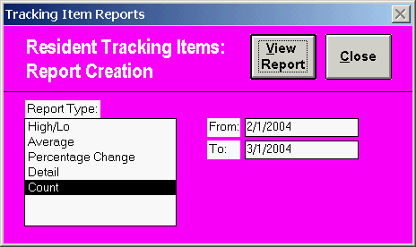

Part IV

REPORTS MENU
The Reports Menu allows you to create reports to evaluate your facility’s resident care. These reports compare actual and profile service times, examine resident and facility acuity, review the resident services entered by the care staff, and provide the weekly service counts for individual residents. The “Reports Menu” contains the following forms:

Actual and Profile Time
Resident Time
Service Entry Review
Resident Service Review

Exhibit 25: Reports Menu

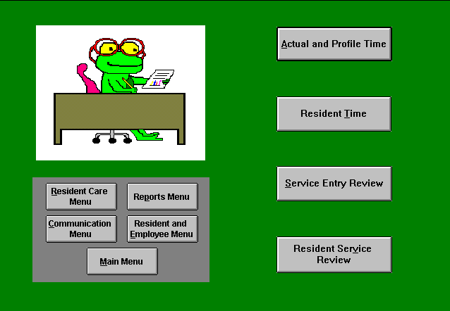

ACTUAL AND PROFILE TIME REPORTS
The purpose of this form is to provide you with reports that compare actual and profile service times. Actual time represents the amount of time that your care staff spent providing services to your residents. Profile time, which is computer calculated, is based on the services needs of residents entered in the Resident Service Profiles. These reports provide valuable insight into shift and unit staffing needs. Specifically, this form allows you to open the following three reports “Actual and Profile Time,” “Actual and Profile Service Time By Unit,” and “Care Level Graphs.”

Each of the aforementioned reports is based on a week. After selecting the report you wish to view, enter any date within the week you desire for your report. Pressing the VIEW FORM button will open the specified report for viewing and/or printing. Clicking the CLOSE button will close this form and return the user to the Reports Menu.

Note: After closing a selected report, you are returned to this form. Since the actual and profile records have already been compiled for the given date, you can open another report based on the supplied week very quickly. If you change the date or close this form and reopen it, the program will have to recompile the records.
Exhibit 26: Actual and Profile Time

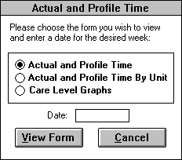

Actual and Profile Service Time
This report calculates the profile and actual time for each weekday and shift for the week specified in the Actual Profile Service Reports form. Actual time represents the amount of time that your care staff spent providing services to your residents, while the profile time sums the time required to perform the services needs of residents entered in the Resident Service Profiles. By allowing you to examine your facility’s aggregate resident service needs by shift and weekday, this form can help to more effectively schedule your care staff. Comparing actual and profile time, reveals how well a care staff team is meeting a given weekday shift’s assigned resident services. Clicking the PRINT button will print the form, while the CLOSE button returns you to the “Actual and Profile Time Reports” form. The “Actual and Profile Service Time” report allows the use of the Sort Options Menu.

Exhibit 27: Actual and Profile Service Time

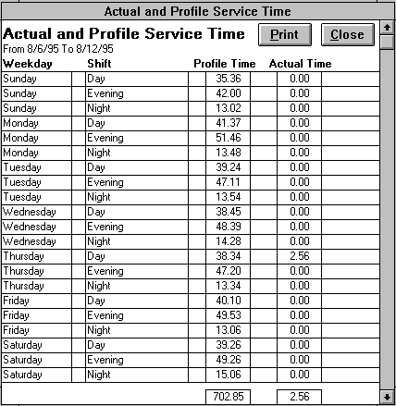

Actual and Profile Service Time By Unit
This report is similar to the “Actual and Service Time” report in its calculation of profile and actual time. However, this report calculates these times by unit designation as well as weekday and shift for the specified week. By including unit designation, you can review resident service needs not just for the entire facility, but also for a specific unit designation. This allows you to staff according to resident need on a dedicated care unit. Comparing actual and profile time, reveals how well a care staff team is meeting a given unit designation service load on a weekday shift basis. Clicking the PRINT button will print the report, while the CLOSE button returns you to the “Actual and Profile Time Reports” form. The “Actual and Profile Service Time By Unit” report allows the use of the Sort Options Menu.

Exhibit 28: Actual and Service Time By Unit

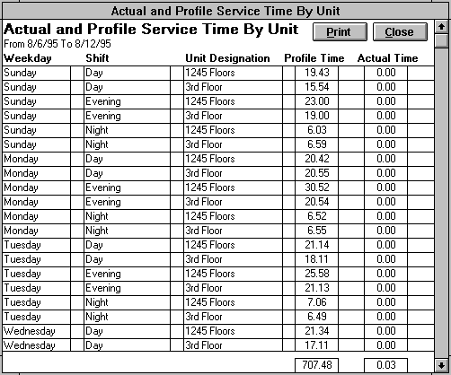

Care Level Graphs
To open this report in the “Actual and Profile Time Reports” form, select the care level graphs option and enter the date for the desired week. Three interrelated graphs, which group residents by care level, constitute this report. A care level is a resident classification type, which groups residents according to their service, needs. Each care level is defined by a time range measured in minutes. Therefore, you classify a resident into a care level based on the amount of time it takes the care staff to perform a resident’s services on a daily basis. The care coordinator in the “Software Options” form determines the resident care levels and their corresponding time ranges.

This first graph, “Actual Service Time By Care Level” pie graph, illustrates the percentage of services performed by the care staff during a week for each resident care level. The second pie graph, “Resident Count By Care Level,” complements the first pie by revealing each care level’s percentage of the resident population. In the exhibit below, you can see how a fairly small portion of your resident population can consume a large portion of your care staff resources. The bottom graph, “Actual and Profile Time By Care Level,” contrasts the actual and profile time for the different care level classifications. Clicking the PRINT button will print the graphs, while the CLOSE button returns you to the “Actual and Profile Time Reports” form.
Exhibit 29: Care Level Graphs

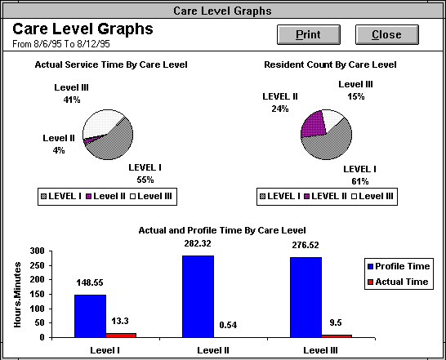

RESIDENT TIME REPORTS
This form provides you with reports that examine resident and facility acuity. While resident profile time is calculated from service time weights, resident service time is measured in weighted time units consisting of both a service time and an employee weight. Firstly, every service that your care staff provides has a time weight expressed in minutes. This time weight is the average amount of time it should take to complete the service. Secondly, the time unit is weighted depending on who performs the service. This weighting factor is derived from the employee’s wage per hour. The unit is weighted by service performer because a facility often has care providers with differing education, experience and abilities. For example, typically a nurse has more training, resident care skills, and education than a nursing aide. A facility compensates the nurses at a higher pay level than aides for these reasons. Therefore, the resident services performed by the nurse should be weighed more heavily than those by the aide. The wage per hour represents a good weight factor since a facility usually basis its compensation on the aforementioned reasons. Furthermore, utilizing an employee’s wage per hour allows you to determine the labor costs of resident care. The care coordinator specifies in the “Software Options” form the desired standard employee weight unit.
Example of how Resident Service Time is calculated: A resident receives the following services in a week:

Service | Time Criteria | # Times done | Service Time Weight | Completed By | Wage/Hr
Medication Distribution | 0 - 5 | 7 | 2.5 | John Smith, aide | $7.00
Insulin Injection | 0 - 10 | 14 | 5 | Val Johns, nurse | $14.00
Medication Distribution | 0 - 5 | 7 | 2.5 | Jill Owens, aide | $8.00

Calculation:
Service Time  7 x 2.5 x 7.00 = | 122.5 | 1242.5 / 7(# of days in a week) = 177.5
14 x 5 x 14.00 = | 980 | 177.5 / $8.00(standard employee weight unit) = 22/DECM per resident
7 x 2.5 x 8.00 = | 140 | *DECM stands for Daily Employee Care Minutes
Total | 1242.5
In this example, the resident averaged 22 employee minutes of services per day for the week.

Specifically, this form allows you to open the following five reports “Resident Service Time By Week,” “Average Resident Service Time,” “Resident Service Time Out of Range,” “Resident Profile Time”, and “Unit and Care Level Acuity Averages.” Each of these reports except “Resident Profile Time” are based on a user specified date range, which cannot span over more than 10-week periods. In this program a week starts on Sunday and ends on Saturday. The reports opened will only contain information concerning the date range specified. Days in the same week that do not fall within the date range will not be included. Pressing the VIEW FORM button will open the specified report for viewing and/or printing. Clicking the CLOSE button will close this form and return the user to the Reports Menu.

Note: After closing a selected report, you are returned to this form. Since the records have already been compiled for the given date range, you can open another report based on the current date range very quickly. If you change the date range or close this form and reopen it, the program will have to recompile the records. This does not apply to the “Resident Profile Time” report, which is based on the current date instead of a user defined date range.

Exhibit 30: Resident Time Reports

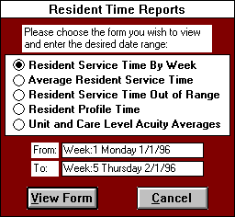

Resident Service Time By Week
This report lists in alphabetical order all the current residents, their care levels, and their weighted resident service time for each week in the specified date range. The aim of “Resident Service Time By Week” is to enable you to examine individual resident care needs over time in week increments. Reviewing a resident’s service trends can help you to identify those residents whose service needs are changing, allowing your care staff to adjust to the resident’s new service requirements, instead of waiting for a cataclysmic event to occur to initiate a change in care. Additionally, you can use this report to monitor the effectiveness of different care strategies on a resident’s care needs.

These resident service times reflect the average daily weighted care staff time utilized by the resident during each week in the range. The service times are calculated only for the days that the resident is in the facility. Furthermore, if the specified date range covers a part week, the service time calculates only for the days within the date range. Clicking the PRINT button will print this report, while the CLOSE button returns you to the “Resident Time Reports” form. The “Resident Service Time By Week” report allows the use of the Sort Options Menu.

Exhibit 31: Resident Service Time By Week

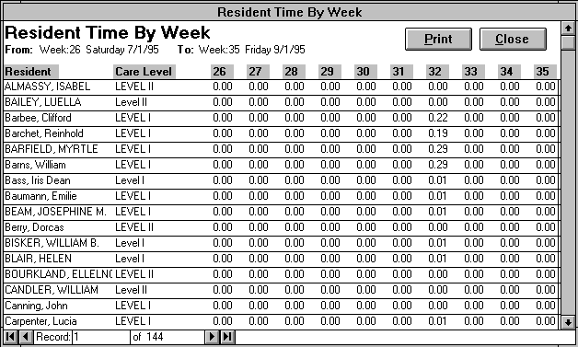

Average Resident Service Time

Like “Resident Service Time By Week,” this report enables you to examine individual resident care needs over time. Unlike that report, “Average Resident Service Time” does not break up the weighted resident service time into week increments for trend analysis. Instead, this report returns the average weighted resident service time over the entire date range. These averages are based on the resident’s census days, the number of days the resident is in the facility over the date range. For example, if a resident has just moved into the facility or was in the hospital during the date range, then he/she would not be included for the entire date range. The census days only count the days that a resident is physically in the building. If the resident is in the facility for even part on a day, this counts as a census day. In addition, the report lists the resident’s assigned care level. A care level is the resident classification type, which groups residents according to their service needs. Each care level is defined by a time range measured in minutes. The care coordinator in the “Software Options” form determines the resident care levels and their corresponding time ranges. Clicking the PRINT button will print this report, while the CLOSE button returns you to the “Resident Time Reports” form. The “Average Resident Service Time” report allows the use of the Sort Options Menu.

Exhibit 32: Average Resident Service Time

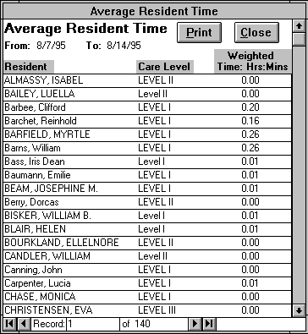

Resident Service Time Out of Range

Like “Average Resident Service Time,” this report enables you to examine the average weighted resident service time over the entire date range. These averages are based on the resident’s census days, the number of days the resident is in the facility over the date range. Unlike that report, “Resident Service Time Out of Range” does not include all the current residents. Instead, it only details those residents whose average service time does not fall within the time parameters of their designated care level. The care coordinator in the “Software Options” form determines the resident care levels and their corresponding time ranges. The Care Level Time Difference field provides the difference between the resident’s weighted time and the care level time ranges. If the time difference is a negative number, then the number shows how many hours.minutes the resident’s service is less than the minimum parameter for the care level. A positive difference reveals how much time the resident’s service time is greater than the maximum parameter for the specified care level. Therefore, this report helps you to determine whether or not a resident should move up or down in care level. With the proper permissions, you can update a resident’s care level though the “Resident Information” form. Clicking the PRINT button will print this report, while the CLOSE button returns you to the “Resident Time Reports” form. The “Resident Service Time Out of Range” report allows the use of the Sort Options Menu.
Exhibit 33: Resident Service Time Out of Range

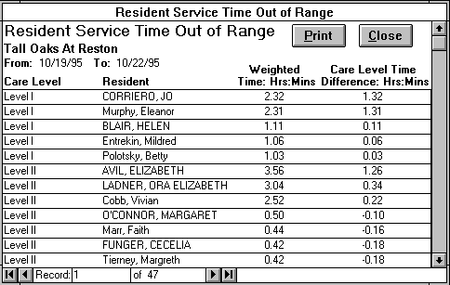

Resident Profile Time
While the other “Resident Time Reports” examine the actual resident service time, this report analyzes each resident’s profile time. Actual resident service time represents the amount of time that your care staff spent providing services to your residents weighted by the care staff service provider. On the other hand, profile time, which is computer calculated, is based on the services time weights of the services entered in the Resident Service Profiles. Unlike the other reports, you are not required to enter a date range since this report will always reflect the current week. This report lists in alphabetical order all the undischarged residents, their care levels, their average daily profile service times and service counts, and their weekly profile services times and service counts. This report allows you a concise overview of each resident’s profile in terms of time and service count. In combination with other “Resident Time Reports”, “Resident Profile Time” also provides a useful comparison between a resident’s profile time needs and actual weighted service time. Clicking the PRINT button will print this report, while the CLOSE button returns you to the “Resident Time Reports” form. The “Resident Profile Time” report allows the use of the Sort Options Menu.
Exhibit 34: Resident Profile Time Report

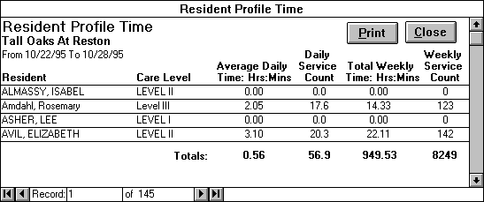

Unit and Care Level Acuity Averages
While the other “Resident Time Reports” review specific resident’s weighted time, this report analyzes weighted service time and acuity at the more macro level of unit designation/care level and facility averages. This report lists the census days, number of residents, and the actual and projected acuity time for each unit designation and care level. The census day’s column enumerates the total number of days the residents were in the facility for the specific unit designation and care level. The number of residents includes all residents who were in the facility during the selected date range. Actual acuity time divides the total amount of weighted resident service time by the total number of census days the residents were in the facility. On the other hand, projected acuity time is the average of each resident’s weighted service time divided by that resident’s census days. Therefore, in actual acuity time resident that have more census days are weighted more heavily, while in projected acuity all residents are weighted equally regardless of their respective census days.

This report provides an overview of the resident service needs for each unit designation and care level. The actual and projected acuity numbers provide a standard for comparing resident need across unit designations, care levels, and even different facilities. Multiplying the actual acuity, standard employee weight unit, and the number of resident census days will also provide an accurate measure of your labor cost for the specified date range. Performing the same calculation by substituting projected for actual acuity can help predict your labor costs in the near future. Clicking the PRINT button will print this report, while the CLOSE button returns you to the “Resident Time Reports” form. The “Unit and Care Level Acuity Averages” report allows the use of the Sort Options Menu.
Exhibit 35: Unit and Care Level Acuity Averages

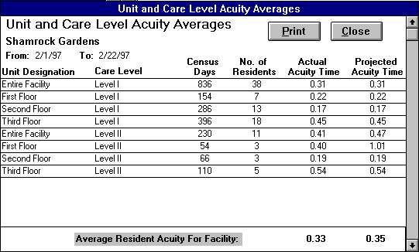

SERVICE ENTRY REVIEW REPORTS

The purpose of this form is to provide you with reports that review the resident services entered by the care staff and staff positions performing these services. Specifically, this form allows you to open the two reports entitled “Service Entry Review” and “Services By Position.” These reports are based on a user specified date range, which cannot exceed 7 days. The reports opened will only contain information concerning the date range specified. Pressing the VIEW FORM button will open the specified report for viewing and/or printing. Clicking the CLOSE button will close this form and return the user to the Reports Menu.

Note: After closing a selected report, you are returned to this form. Since the records have already been compiled for the given date range, you can open another report based on the current date range very quickly. If you change the date range or close this form and reopen it, the program will have to recompile the records.
Exhibit 36: Service Entry Review Reports

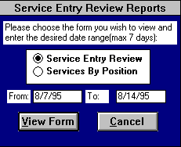

Service Entry Review
This report displays all the service records entered by the care staff through the “Resident Service Entry” form for the specified date range. The care coordinator can utilize this form to review an employee or resident service records for a given shift and/or date range. Furthermore, the care supervisor can delete an incorrect employee entry by clicking on the record selector(s) of the appropriate record(s) and pressing the Delete key from the keyboard. “Service Entry Review” contains the following fields:

Fields
Employee Name - the name of the care provider who performed the service.

Resident Name - the resident for whom the care provider performed the service.

Service - the service performed by the care provider. Each service has a time criteria associated with it.

Time Criteria - service time range measured in minutes.

Date - the date the resident service was provided.

Shift - the shift the resident service was provided.

Filter Options
The filter options provide an efficient way to extract specific information from the resident service records. To initiate a filter, click on the option button () to the left of the desired filter selection to open a list of choices. (For example, choosing the shift option opens a list of all your entered shifts.) Next, select the desired item from the list. Then you can either choose another filter selection to refine your list even more, or process the records with the current selection by clicking the FILTER button. Pressing the FILTER button reduces the records to the defined filter option selections. Click the UNFILTER button to show all the service records again. The following filters are located in the upper left-hand side of the form:

Employee - all employees who entered services over the date range specified in “Service Entry Review Reports.”

Resident - all residents who received services over the specified date range.

Date Range - any date range selected within the date range specified in “Service Entry Review Reports.”

Shift - within the given date range, all shifts the care staff performed resident services.

You can print this report by clicking the PRINT button or close it with the CLOSE button. This report also allows the use of the Sort Options Menu.
Exhibit 37: Service Entry Review

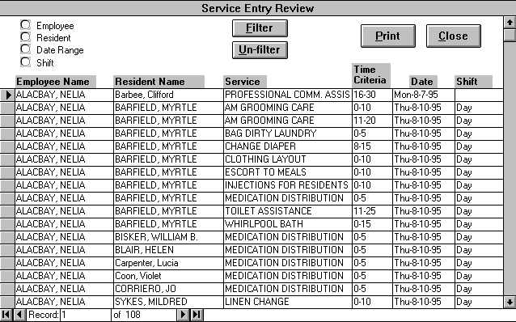

Services By Position
This form lists the resident services grouped by employee position for the designated date range.
“Services By Position” contains the following fields:

Fields
Service - the service performed by the care provider. Each service has a time criteria associated with it.

Time Criteria - service time range measured in minutes.

Position - an employee’s job title. Each employee’s position is entered through the “Employee List” form. Do not confuse ‘position’ with ‘staff type’, which is used in determining care staff assignments.

Count - totals the number of services that were entered by employees for a specific service and position.

Time - tabulates in hours.minutes the amount of time spent by the indicated employee position to perform the given service(s). The time is calculated from the service time weights specified for each service in the “Service List” form.

By reviewing what services the various employee position groups are performing, you can discover if the appropriate staff is providing resident services. For example, in viewing this report, you learn that administrative staff is completing a large number of cognitive impairment services. This information might lead you to the conclusion that mainstreaming your cognitive impaired residents is not an effective care strategy for your facility. You can print this report by clicking the PRINT button or close it with the CLOSE button. This report allows the use of the Sort Options Menu.

Exhibit 38: Services By Position

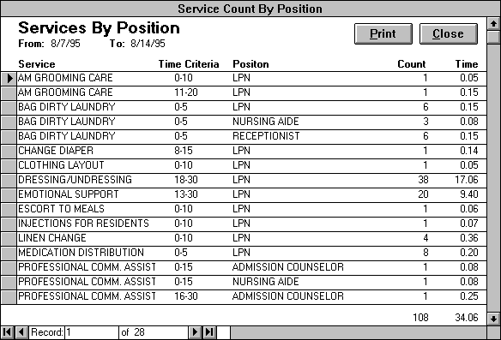

RESIDENT SERVICES REVIEW REPORTS
While the “Resident Time Reports” form creates reports analyzing resident weighted service time, this form produces reports that emphasize the weekly service counts for individual residents. Specifically, this form allows you to open the following four reports: ”Actual and Profile Service Count”, “Resident Services Review”, “Resident Service Totals” and “Selected Residents Services Review.” All of these reports are based on a user specified date range. “Resident Services Review” and “Selected Residents Services Review” tabulate service counts and times for each week period covered by the specified date range. (In this program, a week period runs from Sunday to Saturday.) These reports will count services for the entire week period(s) your date range spans. Conversely, “Actual and Profile Service Count” and “Resident Service Totals” calculate service counts and times for the specified date range, not each week period in the range. You can select “Actual and Profile Service Count”, “Resident Services Review”, or “Resident Service Totals” for viewing and/or printing by pressing the VIEW FORM button.
Exhibit 39: Resident Services Review Reports

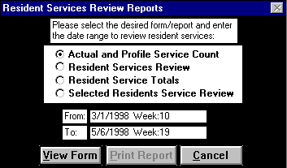

On the other hand, choosing the “Selected Residents Service Review Report” option, opens the bottom half of the “Resident Services Review Reports” form, disables the VIEW FORM button, and enables the PRINT REPORT button as shown below in the exhibit. After selecting the desired residents, click the PRINT REPORT button to print out this report. Click on the CANCEL button to return to the Reports Menu.

Note: After closing a selected report, you return to this form. Since the records have already been compiled for the given date range, you can open another report based on the current date range very quickly. If you change the date range or close this form and reopen it, the program will have to recompile the records.

Exhibit 40: Resident Services Review Reports

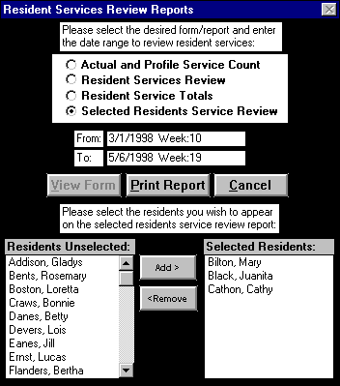

Actual and Profile Service Count
The primary purpose of this report is to allow you to compare the number of services performed for a resident versus the number of services assigned to a resident over a user specified date range. The actual count field reflects the services the care staff has entered through the “Resident Service Entry” form for the specified date range. The profile count field calculates the services assigned from the residents service profile by using the services start and end dates while taking into account any resident LOAs.

The filter options provide an efficient way to view specific information from the actual and profile service count records. To initiate a filter, click on the option button () to the left of the desired filter selection and choose the desired item from the list of choices. Then you can either choose another filter selection to refine your list even more or process the records with the current selection. Pressing the FILTER button reduces the records to the defined filter option selections. Click the UNFILTER button to show all the records again. The following filters are located in the upper left-hand side of the form:

Resident - This list contains all residents entered through the “Resident Information” form except those who have been discharged.

Individual Service - This list contains all services performed over the specified date range.

Multiple Services - This filter allows you to filter by multiple services. Choosing the ‘Add New/Edit’ item from this list opens the “Multiple Service Filter Selection” form, which allows you to define or edit multiple service filters by determining what services comprise each filter.

Click the PRINT button to print the filtered or unfiltered report records. Select the CLOSE button to exit and return to “Resident Services Review Reports”. This report allows the use of the Sort Options Menu.

Exhibit 41: Actual and Profile Service Count

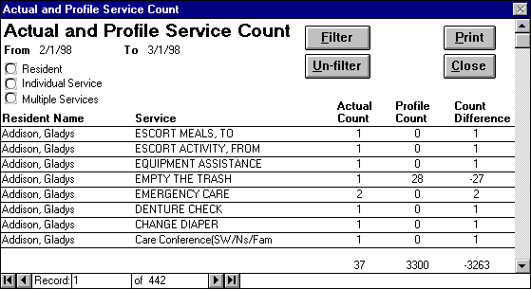

Resident Services Review
This primary purpose of this report is to inform you of the various services a resident receives in a given week period. Additionally, this report examines how many times a resident received a service during a week while calculating the weighted service time.

The filter options provide an efficient way to view specific information from the resident service review records. To initiate a filter, click on the option button () to the left of the desired filter selection and choose the desired item from the list of choices. Then you can either choose another filter selection to refine your list even more or process the records with the current selection. Pressing the FILTER button reduces the records to the defined filter option selections. Click the UNFILTER button to show all the records again. The following filters are located in the upper left-hand side of the form:

Filters
Resident - list containing all residents entered through the “Resident Information” form except those who have been discharged.

Date Range - the dates entered in this range will be converted to their corresponding week periods. You cannot select any date outside the range specified in “Resident Services Review Reports.”

Click the PRINT button to print the filtered or unfiltered report records. Select the CLOSE button to exit and return to “Resident Services Review Reports.” This report allows the use of the Sort Options Menu.

Exhibit 42: Resident Services Review

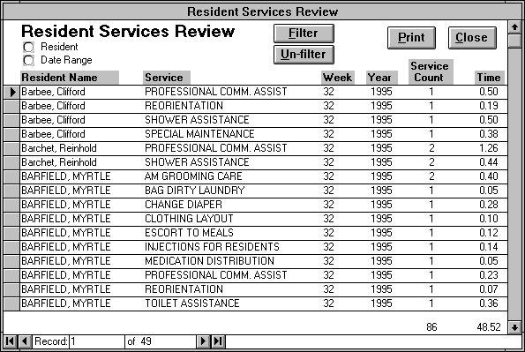

Resident Service Totals

This primary purpose of this report is to inform you of the various services a resident receives over a user specified date range. This report examines how many times a resident received a service during the date range while calculating the weighted service time.

The filter options provide an efficient way to view specific information from the resident service review records. To initiate a filter, click on the option button () to the left of the desired filter selection and choose the desired item from the list of choices. Then you can either choose another filter selection to refine your list even more or process the records with the current selection. Pressing the FILTER button reduces the records to the defined filter option selections. Click the UNFILTER button to show all the records again. The following filters are located in the upper left-hand side of the form:

Resident - This list contains all residents entered through the “Resident Information” form except those who have been discharged.

Individual Service - This list contains all services performed over the specified date range.

Multiple Services - This filter allows you to filter by multiple services. Choosing the ‘Add New/Edit’ item from this list opens the “Multiple Service Filter Selection” form, which allows you to define or edit multiple service filters by determining what services comprise each filter.

Click the PRINT button to print the filtered or unfiltered report records. Select the CLOSE button to exit and return to Resident Services Review Reports. The Resident Services Review report allows the use of the Sort Options Menu.

Exhibit 43: Resident Service Totals

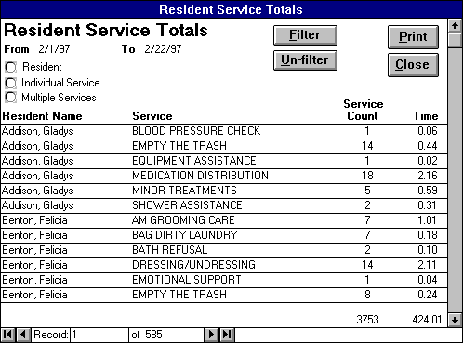

Selected Resident Services Review
Similar to the “Resident Services Review,” this print-only-report shows how many times the resident you select received a service during a week while calculating the weighted service time. Clicking the ‘Selected Resident Services Review’ option opens the bottom half of the “Resident Services Review Reports” form, which enables you to select the desired residents.

Now at the bottom of the form, there are two list boxes, ‘Residents Unselected’ and ‘Residents Selected’ respectively. These two list boxes are mutually exclusive. This ‘Residents Selected’ box is now blank because you have not yet chosen any residents for your report. On the other hand, the ‘Resident Unselected’ box contain all the residents entered in the “Resident Information” form who have not been discharged. You select the residents you want in your report from the ‘Resident Unselected’ list box by either double clicking the desired resident or single clicking the resident and then pressing the ADD button. This action will cause the resident’s name to appear in the ‘Residents Selected’ box and disappear from the ‘Resident Unselected’ box. Removing residents from the ‘Residents Selected’ box works very similarly. You can either double click the unwanted resident in the list box or select the resident and click the REMOVE button. Clicking the PRINT REPORT button will print the selected resident’s service counts and weighted time for each week period spanned by the date range.

Part V.

COMMUNICATION MENU
The forms on this menu help the care staff communicate better among themselves. The “Communication Menu” contains the following forms:

Resident Progress Notes Entry
Resident Progress Notes Review
Resident Progress Notes Count
Communication Messages Entry
Communication Messages Selection

Exhibit 44: Communication Menu

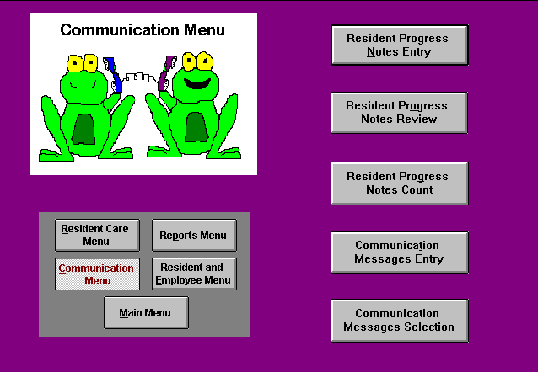

resident progress NOTES ENTRY
The primary purpose of this form is to track changes or significant events in a resident’s care. Upon opening, this form proceeds to a new record, which requires completion of the following fields:

Employee Name - contains the names of all current employees who have been given employee passwords by the care coordinator. Employee passwords are assigned through the “Security Options” form.

Employee Password - the password assigned to an employee. A password is required to ensure that the selected employee enters the nursing note. A nursing note cannot be created without entering the correct password.

Entry Date/Time - the computer’s current date and time is entered by default.

Resident Name -the subject of the note. This list contains the residents currently in the facility.

Progress Note - description of the change or significant event in the specified resident’s care.

After completing your entry, you can choose to enter another nursing note by clicking the NEW RECORD button. If you incorrectly enter information in this form, the UNDO NOTE button will undo all your entry in the current progress note. Clicking the PRINT button will print out the current progress note, while pressing CLOSE exits the form to the “Communication Menu.” Once you exit a progress note, you cannot return to it for editing. If you realize after the fact that you have made a mistake in entering your progress note, enter a new progress note for the appropriate resident, refer to the erroneous note, and explain your error.

Exhibit 45: Resident Progress Notes Entry

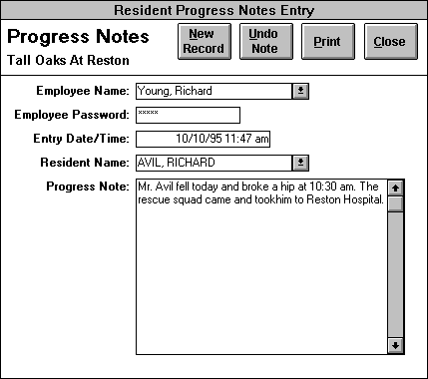

RESIDENT progress NOTES REVIEW
This form allows you to review resident progress notes quickly and easily. Reviewing enables a care staff member to catch up on all the significant changes in resident care since his/her last day worked. Instead of pulling progress note records from across numerous resident charts, you can review progress note records for a specific resident, date range, employee, and/or a combination of the three through these filter options.

To initiate a filter, click on the option button () to the left of the desired filter selection and choose the desired item from the list of choices. Then you can either choose another filter selection to refine your list even more or process the records with the current selection. Pressing the FILTER button reduces the records to the defined filter option selections. Click the UNFILTER button to show all the records again. The following filters are located in the upper left-hand side of the form:

Filters
Resident Filter - contains all residents who have at least one nursing note.

Date Range Filter - the date range for which you wish to review nursing notes.

Employee - list of all employees who have entered a nursing note.

Click the PRINT button to open the “Progress Notes Print Options” form. You have the option of printing out the progress notes records either separated by resident or not separated. Once you select the desired option click PRINT to print the report or CANCEL to cancel the print job and return to “Resident Progress Notes Review”. Select the CLOSE button to exit and return to the “Communication Menu.” This report also allows the use of the Sort Options Menu.

Exhibit 46: Resident Progress Notes Review

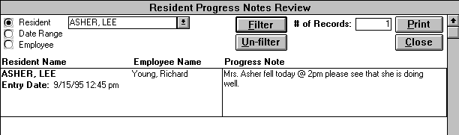

progress NOTES COUNT
In this form, you enter the desired date range to create the “Progress Notes Count Report.” Clicking the VIEW REPORT button opens this report for viewing and/or printing. Press the CANCEL button to return to the “Communication Menu.”

Exhibit 47: Progress Notes Count

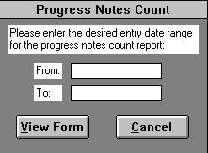

Progress Notes Count Report
The report lists in alphabetical order all the current residents in the facility and the number of progress notes entered for those residents over the date range specified in the “Progress Notes Count” form. This report can help to pinpoint a facility’s more volatile residents for closer monitoring. The PRINT button will print out this report, while the CLOSE button returns you to the “Communication Menu.” This report allows the use of the Sort Options Menu.

Exhibit 48: Progress Notes Count Report

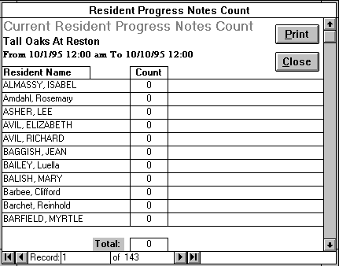

COMMUNICATION MESSAGES ENTRY
This form provides a communication structure for the care staff to exchange important messages. “Communication Messages Entry” opens to a new record. To complete a communication message you should input the appropriate data in the following fields:

Fields
Employee Name - the sender’s name, selected from the list box. This list includes all the current employees.

Entry Date - date the message is entered. This field enters today’s date as the default.

Entry Shift - the shift the message is recorded. This list contains all the shifts entered through “Software Options” form.

Subject Type - one of the following choices: Information Memo, Resident, or Other. ‘Information Memo’ refers to messages that disseminate general information not associated with a specific resident. ‘Resident’ describes those messages that pertain to a specific resident. ‘Other’ covers all other types of messages.

Subject - the primary topic the message addresses.

Note - the message you wish to communicate.

Password Protect - optional protective measure. If a communication message is password protected, only the employee who entered the message and the care coordinator can edit or delete the message. Only employees assigned an employee password by the care coordinator can password protect a communication message.

Message Destination Fields

Shift - the shift to which you wish to “send” the message. This list includes all the facility shifts inputted through “Software Options” form and the choice ‘All shifts.’

Date - the date(s) on which you choose to communicate the message. If you wish to send the message over a date range, click the TO button and enter the second half of your date range in the field that appears.

Entire Facility/Specific Unit option - allows you to direct your message to the entire facility or a specific unit. If you select the specific unit option, you choose which unit designation from the specific unit list that will appear.

Sign Off Person(s) - the person(s) who need to confirm that a message was read and received. You can select one specific person such as the care supervisor for the 3rd floor or a group of people like ‘all nursing aides.’

To enter another new communication message, press the NEW NOTE button. If instead you wish to edit, delete, or simply view a previously entered communication record, utilize the ‘Select the message to edit’ list box at the top of the form. The list box sorts the messages in alphabetical order by employee name, subject type, subject and then entry date. Clicking on the desired communication message makes that record current. If you select a password protected communication message, you cannot edit or delete the message unless you click the UNLOCK NOTE button and supply the correct employee password in the “Password Entry” form that appears.

You should delete any of your erroneous messages by clicking on the DELETE button. If you realize that you do not want to enter a message, the UNDO RECORD button erases entry in the current communication message. Selecting the CLOSE button closes the “Communication Messages” form and returns the user to the “Communication Menu.”

Exhibit 38: Communication Messages Entry

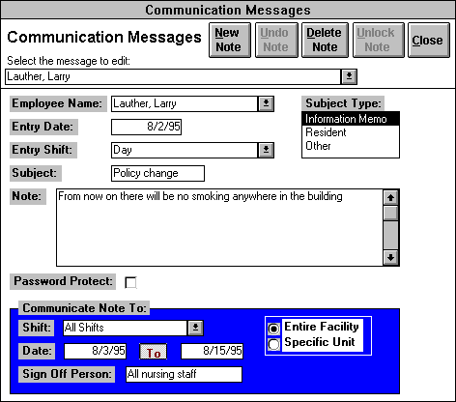

COMMUNICATION MESSAGES SELECTION
This form opens a report, which enables you to view all the messages that have been “sent” to the specified shift and date. Each shift the care supervisor should utilize this form to create the “Communication Messages” report to review the messages for that shift and date. You can view messages for either the entire facility or a specific unit. If you choose the specific unit option (top, center of form), then the specific unit field will appear and the desired unit designation should be selected. Next, select the appropriate shift and date (the defaults is today’s date). Clicking the MESSAGES button opens the “Communication Messages Report” for viewing and printing staff messages. The CANCEL button returns you to the “Communication Menu.”
Exhibit 49: Communication Messages Selection

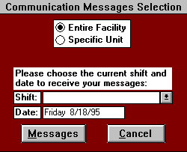

COMMUNICATION MESSAGES REPORT
This report enables you to view all the messages that have been “sent” to the specified shift and date. (And/or unit designation if this option is selected in the “Communication Messages Selection” form). Each shift the care supervisor should utilize this form to review the communication messages for that shift and date. This report is read-only and the messages cannot be edited or deleted. The sign off field indicates which employees should “sign off’ that they have read the specified communication message. Clicking the SIGN OFF button opens the “Message Recipients” form for the currently selected communication message. This form lists all the employees who have already signed off on the selected message by choosing their name form the list of current employees. Any employee can sign off to a communication, by selecting their name from the employee list. If you select a different communication message, the “Message Recipients” form updates to the new message. Clicking the CLOSE button closes the “Message Recipients” form. The PRINT button will print out “Communication Messages,” while the CLOSE button returns you to the “Communication Menu.” The “Communication Messages Report” allows the use of the Sort Options Menu.

Exhibit 50: Communication Messages Report

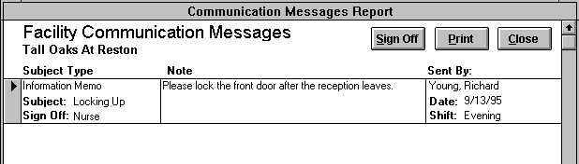

Part VI.

Resident and Employee Menu
This menu allows you to add new residents and employees, update their information, and produce census and communication log reports. The “Resident and Employee Menu” contains the following forms:

Client Contact Information
Resident Information
Resident Face Sheet
Resident Census Options
Resident Discharge
Employee Information
Employee Census

Exhibit 51: Resident and Employee Menu

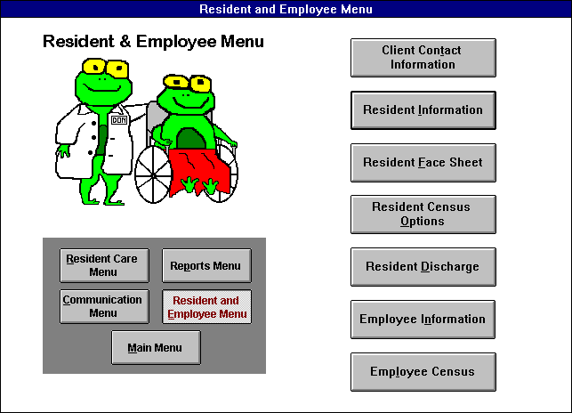

CLIENT CONTACT INFORMATION

The purpose of this form is to collect data about a potential resident. Only one record is needed per potential resident. Before a new resident moves into your facility, you must create a client contact information record for the resident. Next, you should click on ‘Lease Signed’ in the standing field to open a new Resident Information record and fill out the fields for the new resident. If you do not add a new resident, then he/she will not appear in any of your reports or forms, so this process is crucial.

When a marketing associate enters information on this form, she should first check to see if the potential resident is already part of the database. A search can be run by scrolling through the residents' names under the heading ‘Select the resident name to find;’ this feature is found at the bottom of the form. If you are more familiar with the contact's name, the search can be run by scrolling through the contacts' names under the heading ‘Select the contact name to find;’ this feature is also found at the bottom of the form. These two searches can be executed by first clicking the underlined arrow on the right side of the boxes and then using the up and down arrows to scroll through the alphabetized list of names. As the list of names may be very long, there is a useful short cut: First click the underlined arrow on the right side of the box and begin typing the name you are looking for (last name, first name). Once the search box locates the appropriate person, either click the person’s name from the list or press enter. To update these search lists to include any new records you have added since the form has been opened, click on the SEARCH UPDATE button.

Exhibit 52: Client Contact Information

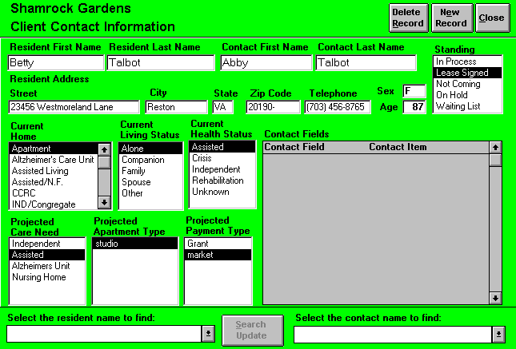

When the resident is already part of the database, the resident's name can be found by scrolling through the list. Once the name is found, the name should be clicked to retrieve the record. You will now see all the data that has previously been entered regarding the resident. A review of this record will provide you with the most recent information. This form should only be kept current up to the time that the lease is signed. For example, it will be useful to know the age of the potential resident; but it is not necessary to know the age of an actual resident. The resident's birthday will be recorded in the “Resident Information” form. Therefore, once the lease is signed, information such as age or payment type should not be altered on the Client Contact Information form. If you need to add a potential resident and contact to the database click the NEW RECORD button. This feature will supply you with a new, blank record. You can move among all of these fields by using the enter key, the tab key, or the mouse.

Fields

Resident first name- Key in the resident's first name.

Resident last name- Key in the resident's surname.

Contact first name- Key in the contact's first name.

Contact last name- Key in the contact's surname.

Resident address- Enter the potential resident's current street address.

City- Enter the city where the potential resident lives.

State- Enter the state where the potential resident lives.

Zip code- Enter the five-digit zip code belonging to the potential resident's address.

Telephone- Enter the area code and phone number of the potential resident.

Age- Enter the potential resident's age.

Sex- Enter an "F" if the potential resident is female; an "M" if he is male.

Along with the resident and contact names, standing is supremely important. Consider that the standing you choose will determine who will remain on the mailing list, who will receive a quarterly newsletter, how the waiting list will be used in an equitable manner, and how the marketing status report will reflect the work you have done. Each potential resident record can only have one standing at one time.

Standing:

In Process- The user can project a lease start date. Selecting this choice will require you to enter the appropriate date in the ‘Projected Lease Start Date’ field.

Lease Signed- Lease signed and move-in date set. Choosing this option will require you to complete the “Lease” form, thus creating a current resident. See the instructions under the heading “Lease Update.”

Not Coming- Choose this when the contact has informed you that the potential resident will not be moving to your property. Or choose this when you have determined that a potential resident will not be moving to your property. Keep in mind that this choice will require completion of the “Reason For Not Coming” form. If a potential resident’s standing is ‘Not Coming,’ clicking ‘Not Coming’ again will allow you to edit the potential resident’s not coming record.

Exhibit 53: Reason For Not Coming Form

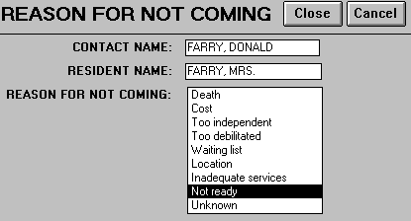

Select the reason that the resident will not be coming to your property:

Death- The potential resident died.

Cost- The potential resident has decided against your property because of its cost.

Too independent- The potential resident is too independent to live in your facility.

Too debilitated- The potential resident requires a level of care beyond your facility's capacity.

Waiting list- The potential resident decided against your property because she desires an immediate placement.

Location- The potential resident decided against your property because of its location.

Inadequate services- The potential resident decided against your property because of the services available.

Not ready- The potential resident did not sign a lease because she was not ready.

Unknown- The reason for not coming is not known.

Exit this form by clicking the CLOSE button. You will now be returned to the "Client Contact Information" form.

“Standing” Continued:
On Hold- No projected lease sign date. The contact remains on the mailing list. Tickle for these leads will probably be 1-180 days.

Waiting List- The decision has been made to move to your property. The potential resident is waiting for something that is currently unavailable (i.e., specific apartment type). These records will not be counted as “hot leads," but rather in a separate waiting list. When you select this option, you will need to complete the "Waiting List" form that appears on your screen. The potential resident's name, the contact name, and today's date will automatically be completed on the form. You need to select what the potential resident is ‘Waiting For:’

Special Income Program - The potential resident wants to participate in a Special Income Program.

Specific floor - The potential resident is interested in a room on a specific floor in your building.

Specific room type - Choose this option if the resident is waiting for a one bedroom, for example.

Combination - For example, choose this option if the resident is waiting for a one bedroom on the third floor.

Other - Choose this option when none of the above correctly describes what the potential resident's is waiting for.

Exhibit 54: Waiting List Form

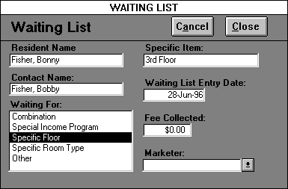

Now complete the ‘Specific Item’ field. If the potential resident is waiting for a studio apartment, you would select ‘Specific Room Type;’ then type in ‘studio.’ Now key in the dollar amount collected for the waiting list fee designated at your property. Return to the "Client Contact Information" form by clicking the CLOSE button. Note: If a potential resident’s standing is “Waiting List,” clicking “Waiting List” again will allow you to edit the potential resident’s waiting list record.

When you get to the fields that have listed choices, select only one answer for each block. Move the mouse (which controls the cursor) so that the arrow is on top of your choice. Now click and your choice will be highlighted.

Current Home:

Apartment- Where a person pays rent to live, or lives with a person who pays rent.

Assisted living- A community of the elderly where medication, health, meals, and the activities of daily living can be monitored.

Assisted/ Nursing facility- A residence where both assisted living and nursing facility care are available.

CCRC- Continued Care Retirement Community. A residential facility where independent living, assisted living and nursing care are all available.

Ind/Assisted- A property where independent and assisted living are both available.

Ind/Congregate- A senior community with minimum supervision. Services such as housekeeping, meals and transportation are available.

Nursing facility- A facility for the dependent where skilled care or nursing services are provided.

Single family home- Where a person owns or pays a mortgage, or lives with someone who owns or pays a mortgage. For example, select this choice when a potential resident is living in a condominium, or lives with a family member in a house.

Current Living Status:

Alone- The potential resident lives alone. This option applies if the potential resident lives by herself in her own home or if she has her own private room at a CCRC.

Companion- The potential resident has a roommate or live-in care provider.

Family- The potential resident is living with a family member.

Spouse- The potential resident is living with a husband or wife.

Other- Choose this option when none of the above correctly describes the potential resident's current living status.

Current Health Status:

Assisted- The potential resident functions with assistance from family, hired help, or any other source.

Crisis- The potential resident is in crisis situation. Choose this option when the potential resident is suddenly in need of immediate care changes.

Independent- The potential resident provides care for herself.

Rehabilitation- The potential resident is in a state of recovery, which has precipitated a change in care needs.

Unknown - Health status of the potential resident is not known.

Projected Care Need: Select the most appropriate care need for the potential resident from the following options:
Independent- Choose this option when the potential resident is looking for independent accommodations.

Assisted- Choose this option when the potential resident desires assisted living.

Alzheimer’s Unit- Choose this option when the potential resident wants a special Alzheimer’s care unit.

Nursing Facility- Choose this option when the potential resident wants to live at a nursing facility.

Projected Apartment Type: Choose the type of apartment the potential resident wishes to occupy. The apartment type choices represent the different room types entered through the “Room Plan” form.

Projected Payment Type - Enter the projected payment classification type for the potential resident’s rent. The payment type choices are entered through payment types on the “Software Options” form.

Contact Fields - these fields specify any additional information the facility wishes to track for your potential residents. The facility captures this additional information by creating resident contact fields within the Market Leap program.

Accuracy and consistency are crucial to this program's effectiveness. Even if it is impossible to obtain the name of the potential resident, a record must still be made. But the resident name fields cannot be left blank. In the case that you do not know the potential resident's name, use the contact's last name for the resident last name, and use "Ms." for the resident's first name. If, for example, you got a message that Cathy Smith called to request a brochure, you would enter the resident name as: Ms. Smith.

When the correct names have been learned, find the resident's record on the "Client Contact Information" form. Position the mouse to the field that you want to correct and key in the accurate information. Keep in mind that there should be one “Client Contact Information” form per potential resident. If a contact is calling you concerning a couple, each potential resident should have his or her own client contact information form. If you accidentally create an additional record, please discard the duplicate by clicking the DELETE RECORD button. Please use the DELETE RECORD button judiciously; deleting a client contact information record also deletes all the contacts associated with that record.

Remember: Prior to lease signing, “Client Contact Information” can be updated. For example, if the contact initially indicates that the potential resident is interested in a one-bedroom apartment, ‘one bedroom’ should be clicked under ‘Project Apartment Type.’ If in a subsequent conversation the contact indicates that the potential resident currently wants to look into a suite, the marketing associate can recall the appropriate record and select "suite;" "one bedroom" will now be unselected.

Click on the CLOSE button to close this form. If you attempt to exit this form without completing some of the crucial fields, the program will remind you of your oversight with a stop message. The message will appear on your screen. After you have read the reminder, click OK and complete the fields. If you are able to exit this form without completing the mandatory fields, your record will not be saved.

RESIDENT INFORMATION

Resident Information Password
When you click on this button in the “Resident and Employee Menu,” if the care coordinator has password protected certain resident functions in the “Software Options” form, then the “Resident Information Password” form appears. These functions include adding or deleting a resident, discharging a resident, and placing a resident on leave of absence. If you enter the correct password in the ‘Password’ field, then you will be able to initiate all the password protected resident functions. Simply click on the VIEW FORM button to open “Resident Information.” However, no password is required to open “Resident Information.” You can press the VIEW FORM button to open this form without specifying a password, but also without access to any password protected functions. Press the CANCEL button to return to the “Resident and Employee Menu.”

Exhibit 55: Resident Password

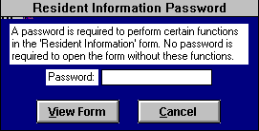

Resident Information Entry

Once you have opened “Resident Information”, you can pull up the desired resident record by selecting the appropriate resident name from the ‘Select current resident’ list box of current residents. . If you need to enter a new resident into resident information, you must do so through the “Client Contact Information” form by clicking on “lease signed” in the standing field for the selected resident. Current residents include all residents who are either moved-in or preparing to move-in into your facility. Residents remain current until they are discharged or as long as their move-out date occurs before the current date. If you wish to select from all residents, click the ALL button. Pressing the ALL button again brings back the current resident list. The Resident Information form contains the following fields:

Exhibit 56: Resident Information

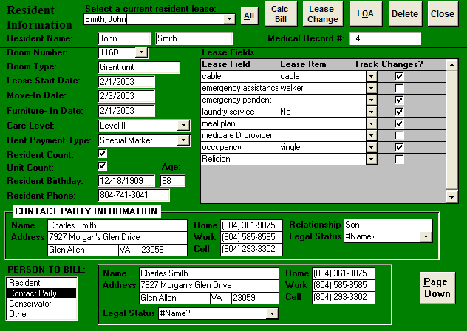

Fields
Medical Record # - Enter the resident’s medical record #, if your facility utilizes such a number to identify its residents.

Room Number- The specific room that the resident will occupy.

Room Type - The room’s apartment type is automatically entered when you select the room number.

Lease Start Date- This is the date that the lessee begins responsibility for the rent.

Move-in Date- This is the date that the resident is physically at the property. This date is not necessarily the same as the lease start date.

Furniture in Date- This is the date that the resident's furniture will be moved to your property.

Care Level- Resident classification type, which groups residents according to their service needs. The marketing coordinator should click the appropriate level of care upon admission. If necessary, the level of care should be changed as potential resident status changes.

Rent Payment Type- Click appropriate payment type. Resident payment types are established in the “Software Options” form.

Resident Count - Mark an “x” in this field if the resident’s is leasing only one unit. If a resident is leasing two units, a resident information record should be created for each unit. In this case, this field should be marked on one record, but not the other. This procedure prevents double counting any residents.

Unit Count- Mark an “x” in this field if only one resident is occupying a unit. If more than one resident is sharing an unit, one resident’s lease should be marked with an “x”, while the other one should not. It is up to the user’s discretion to determine which resident information record to mark. This procedure prevents double counting any units.

Resident Birthday- Supply the resident's date of birth here. Please enter four digits for the year.

Resident Phone - Enter the resident’s phone number if applicable.

Contact Party- The person who receives all communication from the property excluding financial correspondence. This person could be the resident, a family member, etc. Please enter in the contact party’s address information, relationship to resident, phone numbers and legal status.

Person to Bill- If the resident is the Billable Party, select Resident. If the Contact Party receives the bill, select Contact Party. If a person who is neither the Resident nor the Contact Party pays the rent, select Other. You will now be able to complete the name, address, phone numbers, and legal status for this person.

Lease Fields - these fields specify any additional information the facility wishes to track for residents. The facility captures this additional information by creating resident lease fields in the “Resident Lease Field Options” form accessible through the “Facility Options Menu.”

Clicking on the PAGE DOWN button, pages to a second page where more information is captured.

Social Security # - Enter the resident’s social security number.

Medicaid # - Enter the resident’s Medicaid number.

Medicare # - Enter the resident’s Medicare number.

Primary Insurance - Enter the resident primary insurance carrier.

Policy # - Enter the resident’s insurance policy number.

Contact Party #2 Information - A second person to contact in case the first person is unavailable. This person could be a family member, friend, etc. Please enter in the person’s address information, relationship to resident, phone numbers and legal status.

Attending Physician - Enter in resident’s primary physician including address information and phone numbers.

Resident Notes - Type in whatever additional information you wish to record about the resident.

At the top of the form is a series of buttons, which enable you to perform different resident functions. (If a button’s print is highlighted in gray, this means the button is disabled and you do not have permission to perform the given function.) Firstly, clicking on the LOA button, opens the “Leave of Absence” form. Leave of absence refers to any period the resident is physically away from your facility. For example, a resident who has been temporarily admitted to a hospital or leaves for a family vacation is on a leave of absence. The care staff has to track these LOAs through the Leave of Absence form. Selecting the DELETE button will delete the current resident record. Only utilize the DELETE to delete erroneous resident records, never use it to discharge a resident. If you wish to calculate the resident’s contract charges for a specific month, select the CALC BILL button to open the Calculate Bill form. This form automatically calculates the contract charges for the selected bill month and year. Pressing the LEASE CHANGE button opens the “Lease Change Options” form, which allows the user to track individual lease field, changes.

Lease Change Options

This form allows the marketing associate to record and edit changes to the following list of fields: Room Number, Care Level, Rent Payment Type, and any lease fields the user creates in the “Resident Lease Fields” form and designates change tracking. The NEW CHANGE button opens the “Adding Lease Change” form where the user can add a new change in the resident’s lease. Clicking the EDIT/DELETE button opens a list of all the lease changes that have been made to the lease, which the user is currently editing. Selecting the appropriate lease change from the list opens the form “Edit Lease Change.” This form allows the user to edit or delete a specific lease change. Choosing the VIEW CHANGES button opens the Resident Lease Change form, which lists all the lease changes for the current lease. The CANCEL button closes “Lease Change Options.”

Exhibit 57: Lease Change Options

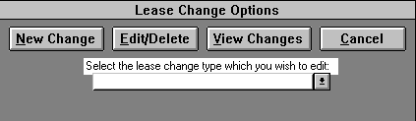

Adding Lease Changes

This form allows the marketing associate to add a lease change to the current resident info record. The user enters this form through the “Lease Change Options” form by clicking the NEW CHANGE button. If the start date is earlier than or the same as the current date, then the current record will immediately reflect the lease change after you close this form. If the start date is later than today’s date, the lease change will automatically update on the correct date. Pressing the CANCEL button, allows the user to delete a mistakenly added lease change. The CLOSE button saves the lease change and exits the form.

Resident Name- This field is automatically filled in with the resident’s name of the current resident info record. Read-only field.

Change Type- Select the type of lease change.

Start Date- The date that the lease change is to take effect.

Lease Item- The specific item to be changed on a lease given a particular change type.

Special Rate - Mark an “X’ in this box, if you wish to bill the specific resident at a different rate than the default rate specified for selected lease item. The care coordinator specifies the default rates for care levels, payment types, and room numbers through the “Software Options” form. The coordinator specifies the resident lease field defaults in the “Resident Lease Fields” form.

Special Default Rate Type - The user only completes this field when he/she desires to enter a special rate. The choices are either a daily or monthly rate.

Special Default Rate - The user only completes this field when he/she desires to enter a special rate.

Comment - The user can enter an explanation or any other important information concerning any lease change.

Exhibit 58: Adding Lease Change

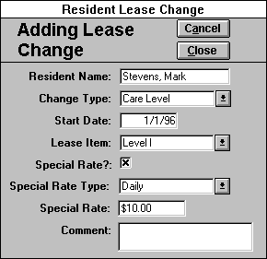

Edit Lease Change

This form allows the user to edit or delete a lease change associated with the current resident info record. The user enters this form through the “Lease Change Options” form by clicking the EDIT/DELETE button and selecting a lease change from the list.

Resident Name- This field is automatically filled in with the resident’s name of the current record. Read-only field.

Change Type- The type of lease change. Read-only field.

Start Date- The date that the lease change is to take effect.

Lease Item- The specific item to be changed on a lease given a particular change type. For example, if the change type is Care Level, the lease item would be either Independent, Level I, Level II, or Level III.

Special Rate - Mark an “X’ in this box, if you wish to bill the specific resident at a different rate than the default rate specified for selected lease item. The coordinator specifies the default rates for care levels, payment types, and room numbers through the “Software Options” form. The coordinator specifies the resident lease field defaults in the “Resident Lease Fields” form.

Special Default Rate Type - The user only completes this field when he/she desires to enter a special rate. The choices are either a daily or monthly rate.

Special Default Rate - The user only completes this field when he/she desires to enter a special rate.

Comment - User can enter an explanation or any other important information concerning any lease change.

Pressing the DELETE button, allows the user to delete a mistakenly entered lease change. The CLOSE button saves the edited lease change and exits the form.

Exhibit 59: Edit/Delete Lease Change

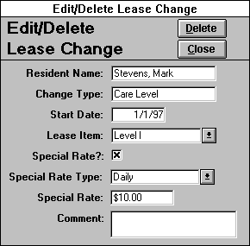

Resident Lease Change

This “read-only” form is simply a listing of all the lease changes associated with the current resident info record. The user enters this form through the “Lease Change Options” form by clicking the VIEW CHANGES button. Use the PRINT button to print out this form and the CLOSE button to close the form. The “Resident Lease Change” form allows the use of the Advanced Options Menu.

Exhibit 60: Resident Lease Change

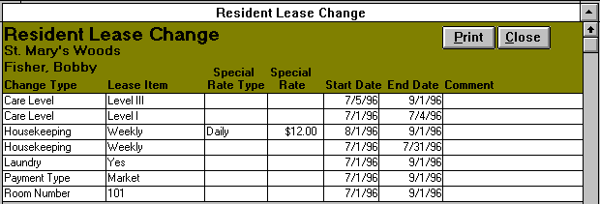

Leave Of Absence

You access this form by clicking the LOA button in the “Resident Information” form. Leave of absence refers to any period the resident is physically away from your facility excluding a permanent discharge. For example, a resident who has been temporarily admitted to a hospital or who leaves for a family vacation is on a leave of absence. Therefore, the “Leave of Absence” lists each of the specified resident’s LOAs the care staff has tracked. To enter a new LOA, the following fields need to be completed:

Leave Date - The date and time that the resident leaves your facility.

Return Date - The date and time the resident is supposed to return to the facility. If this date is unknown, leave this field blank.

Absence Reason -The reason the resident is leaving the building (select one):
Cognitive impairment- The resident's cognitive care needs exceed the care, which your facility provides, and the resident is seeking treatment out of house.

Physical Impairment- The resident's physical care needs exceed the care, which your facility provides, and the resident seeks temporary treatment or rehabilitation outside your facility.

Vacation - The resident is leaving your facility for a family visit or vacation.

Other- None of the above reasons correctly describes the reason a resident is leaving your property.

Location Type - The term that best describes where the resident is going on leave:
Assisted Living - A community of the elderly where medication, health, meals and the activities of daily living can be monitored.

Family home - A place where a resident can live with a family member.

Hospital - A medical facility where the sick or injured can receive emergency or intensive care.

Nursing Facility - A facility for the dependent where skilled care or nursing services are provided.

Vacation Site - A place where the resident goes to relax.

Absence location - The name of the place where the resident is staying on leave from your facility.

The user can edit previously entered LOAs, simply by clicking in the desired field and inputting the correct information. If you discover an erroneous record(s), you should delete the incorrect records by clicking on the record selector(s) and clicking the DELETE button or pressing the delete key from the keyboard. Furthermore, the PRINT button will print this form, while selecting the CLOSE button will close “Leave of Absence” and return you to the “Resident Information” form. The “Leave of Absence” form also allows the use of the Sort Options Menu.

Exhibit 61: Leave of Absence

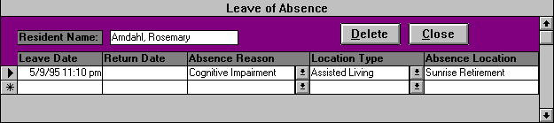

Clicking the CLOSE button will exit this form and return you to the “Resident and Employee Menu.”

RESIDENT FACE SHEET

This read-only form produces a face sheet containing the valuable resident data collected through the “Resident Information” form. (Any changes in information are made through “Resident Information.”) The face sheet contains the following fields: resident, billable party, contact party, contact party #2, attending physician, discharge, and other information. The user can pull up the desired resident record by selecting the appropriate resident name from the ‘Select current resident’ list box of current residents. If you wish to select from residents, click the ALL button. Pressing the ALL button again brings back the current resident list. Once the desired resident record is current, the user can press the PRINT button to print out the resident face sheet. The coordinator can also utilize the “Resident Lease Field Options” form from the “Facility Options Menu” to select which of the user-created lease fields will be incorporated on the “Resident Face Sheet” form. Select the CLOSE button to return to the “Resident and Employee Menu.”

Resident Census Options

This form allows the user to select between the following resident census reports:
“Resident Census Log” and “Resident Census.”

A resident’s appearance on these census reports is dependent on the move-in date entered in the “Resident Information” form and the move-out date inputted if the resident’s discharge has been processed through “Resident Discharge Options.” As long as “today’s date” is after or the same as the move-in date and before or the same as the move-out date, the resident will appear on the census. Pressing the CANCEL button closes this form and returns you to the “Resident and Employee Menu.”

Exhibit 62: Resident Census Options

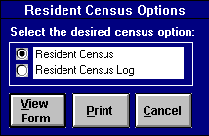

Resident Census Log

This form allows you to print the “Resident Census Log” report, which provides the care supervisor a log to record information concerning the current residents during a shift. (Information that needs to be passed to subsequent shifts should be recorded through the “Communication Messages Entry” form.) Current residents include all moved-in facility residents and those residents whose discharge date does not occur before the current date. The communication log report lists in alphabetical order the current residents’ unit designation(s), names, room numbers, and LOA status. Furthermore this report has a comment field to record resident information, and a No Chg.(abbreviation for No Change) field to denote whether there has been a change or not in a resident’s care needs. At the bottom of this report, the following fields calculate the number of residents in each category for either the given unit designation or the unit designation(s) and the entire facility :

Total In House # - The number of current residents who are not currently LOA.

LOA # -The number of current residents who are out of the building.

Total Census # -The total number of current residents.

Moved-In Within the Week # -The number of current residents who have moved into the facility in the last 7 days.

Admitted # -The number of residents admitted during the shift(entered by the care supervisor).

Discharged # -The number of residents discharged during the shift (entered by the care supervisor).

You can print this report for either the entire facility or a specific unit. If you choose the specific unit option(center of form), then the specific unit field will appear and the desired unit designation should be selected. If the entire facility is selected, the communication log report will print out each unit designation grouping of current residents separately, along with a facility totals page. Next, select the appropriate shift. Select the PRINT button to print out the report.

Resident Census

This form lists the residents in alphabetical order with the following information: resident name, room number, care level, and LOA status. If the resident is currently LOA, then the census also provides the resident’s LOA leave date, LOA return date, and the Absence Location. Select the PRINT button to print the census or the VIEW FORM button to open and view this form. If you open “Resident Census”, then click on the CLOSE button to exit and return to the “Resident and Employee Menu.” The Resident Census allows the use of the Advanced Options Menu.

Exhibit 63: Resident Census

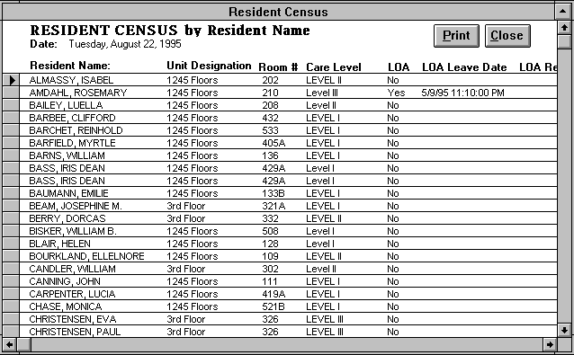

RESIDENT DISCHARGE

Clicking on the RESIDENT DISCHARGE button in the “Resident and Employee Menu” opens the “Resident Discharge Options” form. You use this form to either discharge residents who are leaving your facility or edit the discharge record of residents you have already moved out. To discharge a current resident choose the ‘Discharge resident’ option and then select the resident you desire to move-out from the combination list box. Pressing the VIEW FORM button will open a new discharge record for the selected resident. On the other hand, select the ‘Edit discharge record’ option to edit or delete a resident who has already been move-out. After selecting the desired resident, clicking on the VIEW FORM button opens to the selected resident’s discharge record.

Exhibit 64: Resident Discharge Options

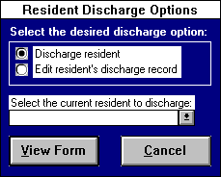

To complete a resident’s discharge record, you need to fill out the following fields:

Fields
Resident Name - The program automatically inputs the resident’s name from the “Resident Discharge Options” form.

Move-Out Date - The date the resident is physically moved out of your facility. If the resident has any LOAs whose leave or return dates are later than this date, the overlapping LOAs will be deleted.

Move-Out reason- This information should be determined by the care staff. Select one of the following:
Cognitive impairment- The resident's cognitive care needs exceed the care, which your facility provides.

Death- The resident died.

Eviction- The resident has been evicted. The facility has processed a Notice to Vacate against a resident's and/ or family's wishes.

Financial- The resident needs to secure different living arrangements due to her financial situation.

Physical Impairment- The resident's physical care needs exceed the care, which your facility provides.

Relocation- The resident is moving because of a change in geographic interest.

Respite- The resident is moving because he/she only wanted a respite stay at your facility.

Other- None of the above reasons correctly describes the reason a resident is moving-out of your property.

Hospitalization- Click this box to indicate that the resident has been discharged to a hospital. A list box of local hospitals will appear. Choose the discharge hospital by pointing and clicking. To add a new hospital to the list, type in the hospital’s name in the list box, press enter, and choose yes at the message prompt.

Location type - Select the term that best describes the resident's new home:
Assisted Living - A community of the elderly where medication, health, meals and the activities of daily living can be monitored.

Family home - A place where a resident can live with a family member.

Hospital - A medical facility where the sick or injured can receive emergency or intensive care.

Independent - A living arrangement where the resident is expected to provide most services for herself.

Nursing Facility - A facility for the dependent where skilled care or nursing services are provided.

None - Option for a resident who is deceased.

Discharge location - The name of the place to which the resident has been discharged. If the resident moved in with her daughter, you would choose ‘Family home’ for location type; for current location, you would type in ‘daughter's house.’

Address - The street number and name of the resident's discharge location.

City - The discharge location city.

State - The discharge location state.

Zip - The discharge location zip code.

Telephone - The area code and telephone number where the discharged resident can be reached.

When you have completed this form, click the CLOSE button and return to “Resident and Employee Menu.” After closing this form, any lease changes due to start after the lease end date are automatically deleted and current lease changes are updated to end on the lease end date. If you press the DELETE button, the discharge record will be deleted, undoing the resident’s discharge and clearing the end dates on the most recent lease changes.

Exhibit 65: Resident Discharge

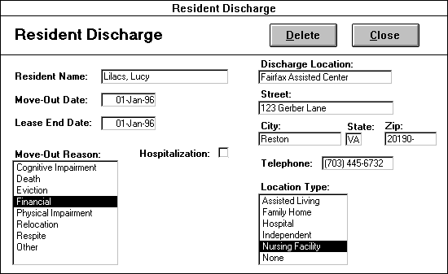

EMPLOYEE INFORMATION
This form allows you to input information concerning the facility’s employees. The employee lists utilized throughout the program are based on the information entered through this form. You can pull up the desired employee record by selecting the appropriate name from the ‘Select current employee’ list box of current employees. Current employees include all staff entered through this form that have either not been terminated or whose termination date occurs after today’s date. If you wish to view a terminated employee’s record, click the OLD button to reveal the ‘Select terminated employee’ list box. Pressing the OLD button again causes the ‘Select current employee’ box to reappear and ‘Select terminated employee’ box to disappear.

Fields
The “Employee Information” form contains the following fields:

Employee First Name - the employee’s given name.

Employee Last Name - the employee’s surname.

Employee Number - a unique numerical code, which identifies an employee. You cannot give two different employees the same employee number.

Department - a group of employees with a similar set of responsibilities. Examples include Administration, Nursing, Food Service, etc.

Position - the employee’s job title.

Cost Center Code - a numerical code, which indicates the cost center to which the employee’s wages will be charged.

Start Date - the employee’s first day of work for your facility.

Termination Date - the employee’s last day of work for your facility. This field should be blank until you are given notice that an employee is leaving your facility.

Exhibit 66: Employee Information

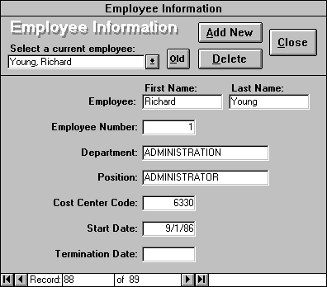

Buttons
At the top of the form is a series of buttons, which enable you to add or delete employees and close this form. Firstly, pressing the ADD NEW button allows you to add a new employee. Before an new employee starts work, you should press this button to create a new, blank employee record. Next, you should fill out the aforementioned fields for the new employee. If you do not add new employees, they will not appear in any of your reports or forms, so this process is crucial.

Selecting the DELETE button will delete the current employee record. Only utilize the DELETE button to remove erroneous employee records such as entering in the same employee twice. Never use it to terminate an employee, enter in the correct termination date instead. Clicking the CLOSE button exits this form and returns you to the “Resident and Employee Menu.”

EMPLOYEE CENSUS
Clicking this button opens the current employee census. Unlike the read-only “Resident Census” form you can edit and/or add employee records through this form. An employee’s appearance on this census is dependent on his/her start date and termination date. As long as “today’s date” is after or the same as the start date and before or the same as the termination date, the employee will appear on the census. Alternately, if you wish to view and/or edit not only current employees, but also all employees, click the SHOW ALL button. Clicking the SHOW ALL button again will return the census to include only the current employees.

This form lists the same fields as “Employee Information:” employee first name, employee last name, employee number, department, position, cost code, start date, and termination date. For users with the appropriate permissions, the DISPLAY WAGE button is shown. Pressing this button, reveals the wage/hr field. This field is security protected because employee compensation is a sensitive matter. Select the PRINT button to print the form and CANCEL to exit and return to the “Resident and Employee Menu.” The “Employee Census” allows the use of the Advanced Options Menu.

Exhibit 67: Employee Census

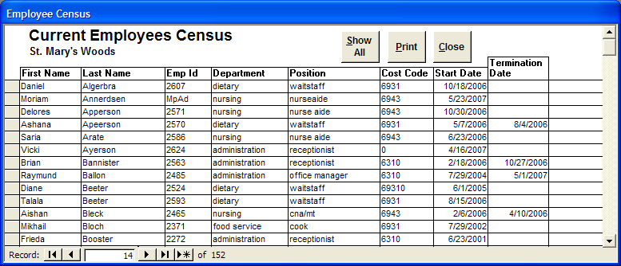

Part VII.

Facility Options Menu
This menu allows the care coordinator to enter general information about the facility required by the Health Leap program. The first five forms should be completed before operating the program because many of the forms in the Health Leap require this information. The “Facility Options Menu” contains the following forms:

Software Options
Service List
Room Plan
Services Assigned By Staff Type
Rooms Assigned By Unit Designation
Archive Service Entry Records
Resident Lease Field Options
Communication Messages Review
Security

Note: You will not be able to access this menu without the appropriate security permissions.

Exhibit 68: Facility Options Menu

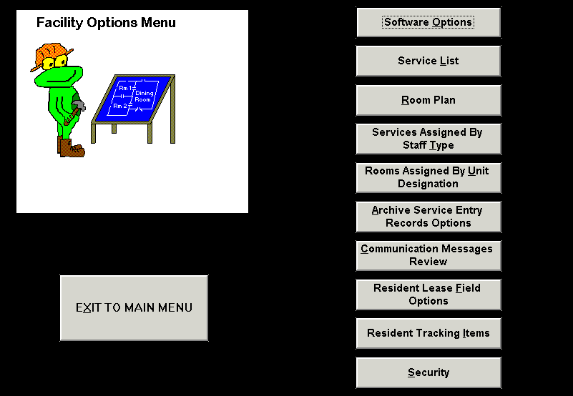

SOFTWARE OPTIONS
This form allows the care coordinator to specify some general options for the Health Leap program. “Software Options” contains the following fields:

Fields
Facility Name/Address - enter your facility’s name address and telephone number.

Resident Info Password - an alphanumeric password. Anyone which wishes to perform the functions in the ‘Require resident info password when’ box will need to supply this password when opening the “Resident Information” form.

Require Resident Info Password When - lists the following resident functions available in the “Resident Information” form: adding, editing, deleting or resident; discharging a resident; entering a resident as LOA. Mark with an ‘X’ the resident functions you wish to password protect. When entering the “Resident Information” form, a user will first be asked to supply the password in “Resident Information Password” form. If none of these functions are marked, then all users have access to these functions and the “Resident Information Password” form is bypassed.

Schedule Application Times - the time you wish the program to perform each of the following operations:
Time to Close Application for Backup - due to the importance of your resident care data, you will want to backup your data daily. Typically, windows backup software will not backup an open application, therefore your application will close each day at the time specified. Any users on the program will be given a 60 second warning to finish what they are doing, before the application closes. The users can reopen the application after the backup software finishes. If this field is left blank then the application will only close at the user’s discretion.

Time To Transfer Daily Service Entry - because you do not want your “Resident Service Entry” form to become overburdened with records and slow the data entry down, the program will move the entry records at the specified time each day. If a user happens to be in “Resident Service Entry” when the transfer is to take place, a 60 second warning message is displayed before this form closes. The program moves any entry records entered before the previous day.

Employee Standard Weight - the dollar amount, which standardizes the employee weight for the weighted resident time. The weighted resident time calculation takes in account the care provider’s wage per hour, weighting the time of a higher paid employee more heavily. The degree of the weight is determined by the amount entered in this field. This allows the care coordinator to express the resident weighted time as a standard unit.

Unit Designations - the different wings or units, which make up the facility (entered by the care coordinator).

Shifts - the different shifts, which the care staff works as, entered by the care coordinator. The coordinator must also specify the following information for each shift:

Shift Start Time - the time the selected shift begins.

Shift End Time - the time the selected shift ends.

Staff Types - the different employee groups, which perform resident services. In the “Services Assigned By Staff Type” form, the care coordinator assigns every resident service to the appropriate staff type. The program in turn will utilize these staff service assignments in creating the “Automatic Staff Assignments.”

Care Levels - the different resident classification types, which you will utilize to group, your residents according to their service needs. Each care level is defined by a time range measured in minutes. The time ranges are set with the amount of weighted service time a resident needs on a daily basis. The coordinator must specify the following information for each care level:

Range Start Time - the minimum amount of service time in minutes a resident requires for a given care level.

Range End Time - the maximum amount of service time in minutes a resident requires for a given care level.

Rate Type - the type of rate that residents will be billed for their care level. The user can choose either a daily or monthly rate.

Rate - the default amount of money that will be billed for a specified care level.

Payment Types - the different payment classification types for resident rent. The user must select a payment basis for each payment type. The payment basis determines if the resident’s rent rate is determined by room type, a flat rate, or a special rate determined for each specific resident. Depending on the payment basis selected, the user may have to enter some or all of the following information: rate type, rate, and room type. The different payment basis and information required for them are listed below:

Room Type - this payment basis requires the user to specify a rate type(daily or monthly) and rate for each type of room for which the coordinator desires to utilize this payment type. The room types available are designated through the “Room Plan” form.

Flat Rate - this payment basis requires the user to specify a rate type(daily or monthly) and rate.

Special Rate - this payment basis requires no additional entry. Residents with a payment type with this payment basis have their billable rent set through the lease change options on the “Resident Information” form.

Click the CLOSE button to exit this form and return to the “Facility Menu.”
Exhibit 69: Software Options

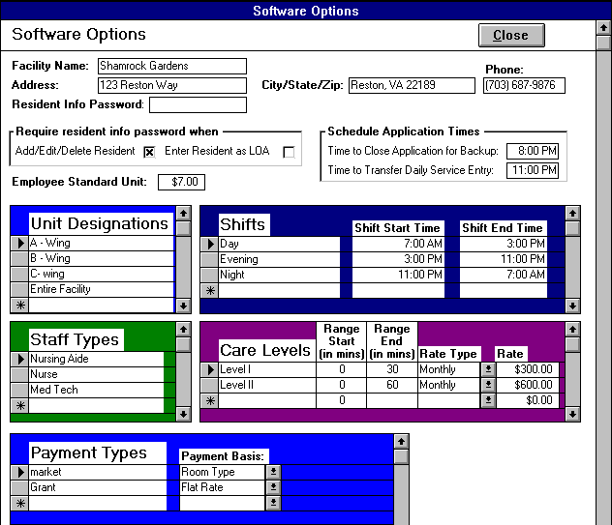

SERVICE LIST

Clicking on the SERVICE LIST button in the “Facility Menu” opens this form. You utilize this form to enter all the resident services your care staff provides. To enter a new service, simply click the ADD NEW button to go to a new record and enter the appropriate information in the following fields:

Fields
Service - the name of the service. The service name has a maximum limit of 25 characters. You can enter the same name for different services, but they must have different service time criteria and time weights.

Time Criteria - the service time range associated with a given service entered in minutes. If a given service takes markedly different amounts of time to perform for different residents, then you should enter the service for each different time period. For example, suppose a whirlpool bath takes 15 minutes for some residents, 30 minutes for others, and 45 minutes for still other residents. You would then create three services each with the name Whirlpool Bath but with time criteria of 0 - 25 minutes, 26 - 40 minutes, and 41 - 60 minutes respectively.

Time Weight - the time weight in minutes for a given service. The service time weight should fall within the given time criteria range. A good rule of thumb is to set your time weight as the average of your minimum and maximum values of your time criteria. The time weight is critical since it is used in expressing resident service needs in terms of time.

Service Definition - description of what the service entails. This allows the care coordinator to communicate to the care staff precise service definitions to help ensure care continuity across service providers. This field has a maximum limit of 100 characters. A selected service’s definition appears when the SERVICE DEFINITION button is clicked in either the “Resident Profile Entry” or “Resident Service Entry” forms.

Active Status - indicates that a service is currently active. The form marks this box with an ‘X’ by default. Only active services are included in the service lists in the “Resident Profile Entry” and “Resident Service Entry” forms. When this box is unmarked, a service becomes inactive and is dropped from the service lists. If you make a service inactive, the “Service Replace” form opens allowing you to replace or delete the now inactive service in the resident service profiles.

Expected Outcome/Goal - This field should reflect the desired result of performing the specific service for the resident. The expected outcome/goal associated with the selected service will be entered automatically when adding a service to a resident profile in the “Resident Profile Entry” form.

Upon opening, this form lists all the currently active services. If you wish to see a list of the inactive services, click the INACTIVE LIST toggle button. Clicking the INACTIVE LIST toggle button again returns the form to the active service list. If you wish to replace or delete a service in the resident service profiles, click the REPLACE button to open the “Service Replace” form. Press the PRINT button to print the Service list and the CLOSE button to return to the “Facility Options Menu.” The “Service List” allows the use of the Advanced Options Menu.

Exhibit 70: Service List

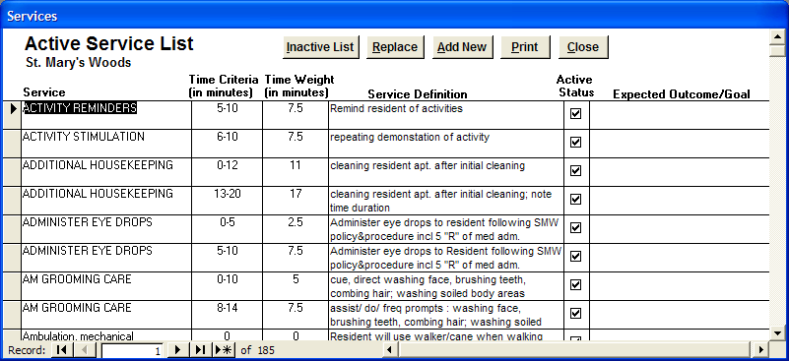

Service Replace
This form allows you to replace or delete a service in the resident service profiles. If marking a service inactive opens this form, the inactive service will automatically be entered in the ‘Selected Service’ field. On the other hand, if you open “Service Replace” by clicking on the REPLACE button in the “Service List” form, then you choose the service you want to replace or delete in the ‘Selected Service’ box. Next, if you only want to delete this service from all your resident profiles without replace it with another service or services, simply click the DELETE button. Your other option is to replace the selected service with another service or services. To replace a service, choose the desired service or services in each ‘Replace Service with’ box and then press the REPLACE button. If you decide not to replace or delete a service in the profiles, click the CANCEL button, which will close the form and return you to the “Service List” form. If you entered this form by marking a service inactive, pressing the CANCEL button will close “Service Replace” and remark the selected service active again.

Exhibit 71: Service Replace

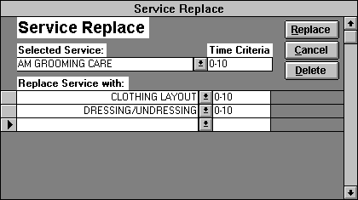

ROOM PLAN

In this form, the care coordinator enters the facility’s room plan. Room Plan is separated into the following two fields:

Fields
Room # - number of the unit.

Room Type - the type of unit (i.e. Studio, Suite, One Bedroom).

Clicking the ADD NEW button, sends you to new room record. If you find an incorrectly entered room record, you should delete the record by clicking on the record selector(s) and clicking the DELETE button or pressing the delete key from the keyboard. The PRINT button will print out this form. The CLOSE button will close the form and return you to the facility menu. The “Room Plan” form allows the use of the Advanced Options Menu.
Exhibit 72: Room Plan

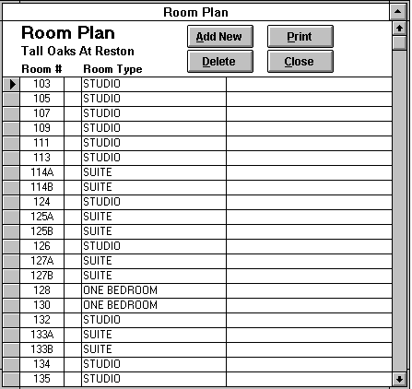

SERVICES ASSIGNED BY STAFF TYPE

To assign services to a specific staff type, first select the desired staff type from the ‘Staff Type’ list box. The staff types in this list box are inputted through the “Software Options” form. On the left side of the form is a list box of services not yet assigned to any staff type. On the right side of the screen is a list box containing the services already assigned to the currently selected staff type. Each service can only be assigned to one staff type. You can add services to your staff type in either of two ways. One technique is simply to double click on the desired service. Another method is to single click the desired service and click the ADD button. Removing services from a staff type works very similarly. You can either double click the unwanted service in the staff assignment list or select the service and click the REMOVE button.

Furthermore, you have the ability to view all the staff types and their assigned services together. Simply click the VIEW ALL button to open the “Specific Staff Services Assigned.” If you wish to print this form, click the PRINT button. Pressing the CLOSE button returns you to the “Services Assigned By Staff Type” form. To exit this form and return to the “Facility Options Menu,” click the CLOSE button. The “Services Assigned By Staff Type” form allows the use of the Sort Options Menu.
Exhibit 73: Services Assignments By Staff Type
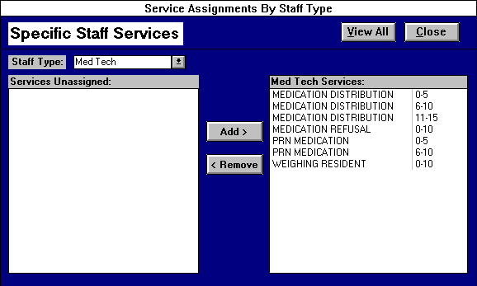

Exhibit 74: Specific Staff Services Assigned
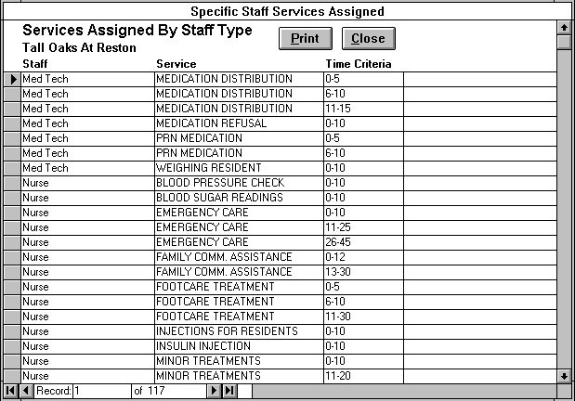

ROOMS ASSIGNED BY UNIT DESIGNATION
To assign rooms to a specific unit designation, first select the desired unit designation from the ‘Unit Designation’ list box. The unit designations in this list box are inputted through the “Software Options” form, while the room numbers are compiled from the “Room Plan” form. These two forms need to be completed before you can make your unit-designated room assignments. On the left side of the form is a list box of room numbers not yet assigned to any unit designation. On the right side of the screen is a list box containing the rooms already assigned to the currently selected unit designation. You can add rooms to your unit designations in either of two ways. One technique is simply to double click on the desired room number. Another method is to single click the desired room number and click the ADD button. Removing room numbers from a unit designation works very similarly. You can either double click the unwanted room number in the unit room assignment list or select the room number and click the REMOVE button.

Furthermore, you have the ability to view all the unit designations and their assigned room numbers together. Simply click the VIEW ALL button to open the “Rooms Assigned By Unit Designation.” If you wish to print this form, click the PRINT button. Pressing the CLOSE button returns you to the “Room Assignments By Unit Designation” form. To exit this form and return to the “Facility Options Menu,” click the CLOSE button. The “Room Assignments By Unit Designation” form allows the use of the Sort Options Menu.

Exhibit 75: Room Assignments By Unit Designation

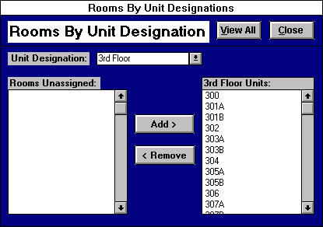
Exhibit 76: Rooms Assigned By Unit Designation

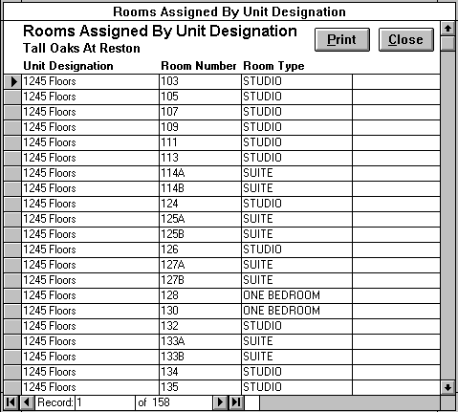

ARCHIVE SERVICE ENTRY OPTIONS
This form allows the care coordinator to archive old service entry records. A service entry record is created for each resident service an employee enters in the “Resident Service Entry” form. Over time, this results in a large number of service entry records. This causes the report generation to slow down since more and more records need to be manipulated. Furthermore, this will cause the program to gradually take up more space on your computer’s hard drive where the data is being stored. Since you typically will not need to review records beyond the most recent couple of months, this form gives you the ability to archive the service entry records to a storage database, restore archived service records from the storage database, or delete archived service records from the storage database.

Select one of the following three archive options:

Archive service entry records(default) - allows the care coordinator to archive all the current service entry records in Health Leap before a user specified date. Clicking the ARCHIVE button will proceed to store all the service entry records performed before the user designated date.

Restore archived service entry records - enables the care coordinator to restore archived service entry records from the storage database into the current Health Leap database. Clicking the RESTORE button will cause all the archived service entry records occurring after the user specified date to be put back in the current database.

Delete archived service entry records - empowers the care coordinator to delete archived service records from the storage database. Usually, you will only want to delete archived records after you have backed up the storage database. Selecting this option reveals the delete options box. You can choose either the ‘Delete by Date’ or the ‘Delete All’ option. If the ‘Delete by Date’ option is selected, you enter a date before which all the archived service records will be deleted when you click the DELETE button. The ‘Delete All’ option takes much less time to process the deletion than ‘Delete by Date.’ When you select ‘Delete All,’ all the archived records in the storage database are deleted once the DELETE button is clicked. You will have the option of canceling a delete operation after the DELETE button is pushed.

Clicking the RECORD COUNT button will calculate the number of service records that will be archived, restored, or deleted for a given archive option. Pressing the CANCEL button will close the form and return the user to the “Facility Menu.”

Exhibit 77: Archive Service Entry Options

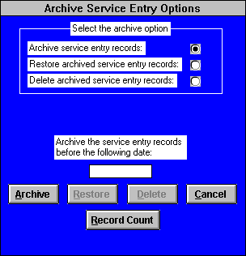

COMMUNICATION MESSAGES REVIEW
This report enables you to view all the messages that have been entered through the “Communication Message Entry” form. Unlike the “Communication Messages” report, the message records can be edited or deleted through this form even if they are password protected. This allows the care coordinator to delete or change inappropriate messages. The care coordinator can utilize this form to review the communication messages for a specific subject type, employee sender, date range, and/or shift through these filter options.

To initiate a filter, click on the option button() to the left of the desired filter selection and choose the desired item from the list of choices. Then you can either choose another filter selection to refine your list even more or process the message records with the current selection. Pressing the FILTER button reduces the records to the defined filter option selections.. Click the UNFILTER button to shows all the message records again. The following filters are located in the upper left-hand side of the form:

Filters
Subject Type - list containing three subject types: Information Memo, Resident, and Other.

Sent by Employee- list of all employees who have entered a communication message.

Date Range - the date range for which you wish to review communication messages.

Shift - all the facility shifts as defined in the “Software Options” form.

Clicking the SIGN OFF button opens the “Message Recipients” form for the currently selected communication message. This form lists all the employees who have already signed off on the selected message by choosing their name from the list of current employees. If you select a different communication message, the “Message Recipients” form updates to the new message. Clicking the CLOSE button closes the “Message Recipients” form. The PRINT button will print out the filtered or unfiltered communication messages including all the employees who have signed off on a given communication message. Clicking the CLOSE button returns the care coordinator to the “Facility Menu.” The “Communication Messages Review” allows the use of the Sort Options Menu.

Exhibit 78: Communication Messages Review

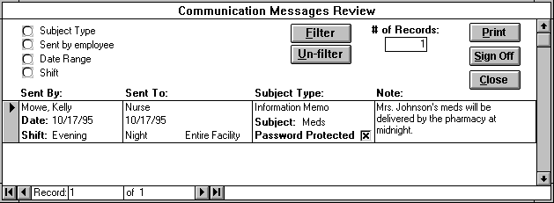

Resident lease field OPTIONS
This form allows the user either to specify additional lease fields on the “Resident Lease Information” form or select which of these lease fields will be incorporated on the “Resident Face Sheet” form. The coordinator chooses one of the following options:

Add/Edit Resident Lease Fields - selecting this option opens the “Resident Lease Fields” form. Through this form user can create new lease fields or edit current lease fields.

Add/Remove Lease Fields on the Resident Face Sheet - selecting this option opens the “Resident Face Sheet Lease Field Selection” form. The coordinator selects which lease fields he/she wants to be
included on the “Resident Face Sheet.”
Exhibit 79: Resident Lease Field Options

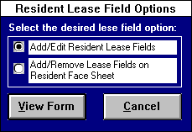

Clicking the VIEW FORM button will open the form associated with the selected option while pressing the CANCEL button returns the care coordinator to the “Facility Menu.”

Resident Lease Fields
You utilize this form to specify any additional information you wish to track for your resident. You capture this additional information by creating resident lease fields, which will in turn appear on the “Resident Information” form. To enter a new resident lease field, simply click the ADD NEW button to go to a new record and enter the appropriate information in the following fields:

Fields
Lease Field - enter a name of the information you wish to capture

Lease Field Items - input the list of options the user has to choose from when entering information for the lease field. If the lease field is a billable item, the user can supply default rates for each lease item. Some lease fields such as addresses will not have any lease field items since the information collected will be unique for each resident. An example of some lease field items would be Catholic, Protestant, Jewish, Muslim, and Other for the lease field Religion.

Track Changes - place a “X’ in this box if you wish to track the changes in information for each resident for the selected lease field. The changes are tracked through the “Lease Change Options” form accessed through the “Resident Information” form.

Billable Item - place a “X’ in this box if the selected lease field is a billable item for your facility. For the billable item lease fields, the user should supply default rates for each lease item. For billable item lease fields, the lease field changes should always be tracked.

Rate Type - this field only appears if the billable item box is marked with an “X”. The user specifies whether the lease field is billed at a daily or monthly rate.

Active Field - indicates that a lease field is currently active. The form marks this box with an ‘X’ by default. Only active lease fields are included in the lease field lists in the “Resident Information” and “Resident Face Sheet Lease Field Selection” forms. When this box is unmarked, a lease field becomes inactive and is dropped from the lists.

Clicking on the DELETE button will delete the selected lease field. (Note: Deactivating the lease field by unmarking the Active lease field is usually the better solution, since you can simply reactivate the field later on if you wish.) Press the PRINT button to print the Lease Fields Report and the CLOSE button to return to the “Facility Options Menu.”

Exhibit 80: Resident Lease Fields

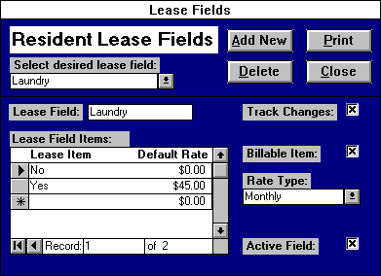

Resident Face Sheet Lease Field Selection
The coordinator assigns a resident lease field to the “Resident Face Sheet” through this form. On the left side of the form is a list box of lease fields not currently incorporated in the face sheet.. On the right side of the screen is a list box containing the rooms already assigned to the resident face sheet. You can resident lease fields to the face sheet in either of two ways. One technique is simply to double click on the desired lease field. Another method is to single click the desired lease field and click the ADD button. Removing lease fields from the face sheet works very similarly. You can either double click the unwanted lease field in face sheet fields list box or select the lease field and click the REMOVE button. The selected lease fields will appear on the “Resident Face Sheet” under the other information heading in their selection order. Pressing the CLOSE button returns you to the “Facility Options Menu.”

Exhibit 81: Resident Face Sheet Lease Field Selection

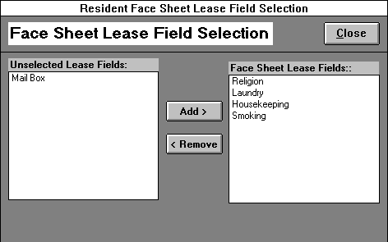

Resident Tracking Items
You utilize this form to specify any additional information you wish to track for your resident. You capture this additional information by creating resident tracking items, which will in turn appear on the “Resident Tracking Entry” form. To edit an existing resident tracking item, select from the pull down list at the top of the form. To enter a new resident tracking item, simply click the ADD NEW button to go to a new record and enter the appropriate information in the following fields:

Fields
Tracking Item - enter a name of the information you wish to capture

Item Type – select the appropriate item type for the specified tracking item. Item Type choices: number, text, text with set value, and text and number.

Number - requires only a numerical value for the tracking item. Example: Resident weight.

Text – requires only a text value for a tracking item. Example: Ability to Transfer.

Text with set value – requires a text value with a predetermined associated number value. Example: Food Consumption.

Text and Number – for those tracking items that require both a text entry and a number entry.

Tracking Item Choices - input the list of options the user has to choose from when entering information for the tracking item. If the tracking item’s item type is text with set value, the user should supply choice value numbers for each text item choice. See the Food consumption example in the exhibit below. There are no tracking item choices for tracking items with an item choice of number. Some text and text and number tracking items might not have any tracking item choices since the information collected will be unique for each resident.

Active Field - indicates that a resident tracking item is currently active. The form marks this box with an ‘X’ by default. Only active tracking items are included in the tracking item lists in the “Resident Tracking Entry” form. When this box is unmarked, a tracking item becomes inactive and is dropped from the lists.

Clicking on the DELETE button will delete the selected tracking item. (Note: Deactivating the tracking item by unmarking the Active lease field is usually the better solution, since you can simply reactivate the field later on if you wish.) Press the CLOSE button to return to the “Facility Options Menu.”

Exhibit 82: Resident Tracking Items

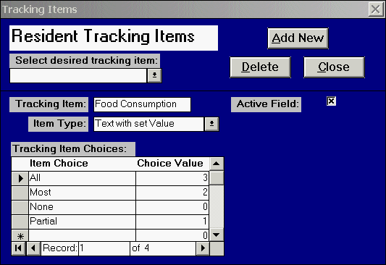

SECURITY OPTIONS
This form, accessed through the “Facility Menu,” allows the care coordinator to devise Health Leap’s security. The program’s security is divided into two main levels: user and employee. User security determines access in opening Health Leap. A user name and password are required each time the program is opened. Conversely, employee password determines access within the program. For example, an employee cannot create a resident progress note without supplying his/her correct password. Therefore the care coordinator has the following security options:

Add New User - creates a new user account.

Delete User - deletes a user account.

Clear User Password - clears a user password in case the password is forgotten.

Change User Password - allows the care coordinator to change an user password.

Add Employee Password - enables the coordinator to create a new employee password account.

Clear/Delete Employee Password - permits the coordinator to either clear an employee’s password or remove the employee from the security account.

Set Object Permissions - enables the care coordinator to set user groups’ permissions for viewing Health Leap menu objects.

Exhibit 83: Security Options

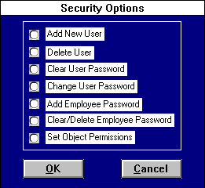

Add New User
The "Add New User" form allows the user that belongs to the admins group to create a new user account for a new user. The coordinator must specify the following information:

New User Name - an alphanumeric string that identifies each user account. The User Name is also used in logging into Health Leap.

User Group - identifies both the type of a user and the permissions granted that user. For example, users who belong to the admins group are allowed to create new account and delete old ones, but users that belong to other groups are not allowed to add or delete accounts. The type of access you want to give to a user depends upon the user’s group designation.

Personal Identifier (PID) - a case-sensitive alphanumeric string 4-20 characters long that Health Leap uses to distinguish each user in a Workgroup.

New Password - a case-sensitive alphanumeric string used for logging into the database. Passwords should contain at least five characters and prove easy to remember but difficult to guess. Keeping the password private prevents a security breach and makes tracking much easier.

Verify - confirms a new password by prompting you to retype the alphanumeric string you have just created.

After the new password is verified, press OK button and the new account will be created. If you decide to cancel creating a new account, press the CANCEL button. After a new account is created, the new user will be able to login to the database with the new user name and password.

Exhibit 84: Create New User

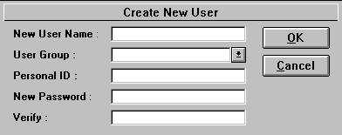

Delete User
"Delete User" allows the users that belong to the care coordinator or admins group to delete a user account. You must pick a user name from the list and press the OK button. If you decide not to delete the user, you can press CANCEL. Once a user is deleted, you cannot retrieve it back. But you can create a new user with the same user name.

Exhibit 85: Delete User

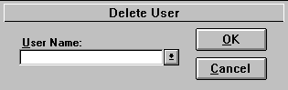

Clear User Password
The "Clear User Password" form enables the users that belong to the care coordinator or admins group to clear a user password of a user. This is used in case the user(s) forgot his or her password and wants to regain access to Health Leap. The admin/coordinator can then clear the password through this form and then create a new password for the user through the “Change Password” form.
You must pick a user name from the list and press the CLEAR PASSWORD button. If you decide not to clear the password, you can press CANCEL button. Once the password is cleared, it is important that the user login to the database and change his or her password. By reducing the number of no-password accounts, the system maintains a higher level of security.
Exhibit 86: Clear User Password

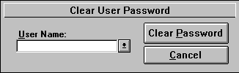

Change User Password
This form allows the care coordinator or admin to change a password to a new password for that user account. The user must enter the old password before the user can change the password. In the case of a password cleared through the “Clear User Password” form, you should leave the old password field blank. Text entered in the password text boxes will be replaced with asterisks to conceal the password. The new password must also be verified. Press the OK button and the new password will be asked on the next log-in. Press CANCEL if you decide not to change the user password. Passwords should have at least five characters (letters and/or numbers), which prove easy to remember but difficult to guess.
Use the Change User Password feature as often as you like. If you feel someone has discovered a user password, use the “Change User Password” form. The password is like a key. It is the user's responsibility in keeping that key safe. The password is used along with the user name for logging in to the database. Without the key, the user will not have access.
Exhibit 87: Change User Password

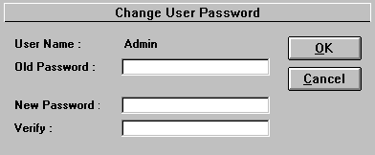

Add Employee Password
The "Add Employee Password" form allows a user belonging to the care coordinator or admins group to create an employee password account. Employees will use their passwords to enter nursing notes and password protect communication messages. If you do not wish an employee to have these capabilities, do not assign them a password. To assign an employee password, the coordinator must specify the following information:

Employee Name - the employee for whom you are assigning a password. This employee list contains all current or newly hired employees who have not been assigned a password.

Employee Password - a case-sensitive alphanumeric string used for logging onto the database. Passwords should contain at least five characters and prove easy to remember but difficult to guess. Keeping the password private prevents a security breach and makes tracking much easier. Employees should change their passwords periodically through the “Change Employee Password” form accessed through the “Main Menu.”

Verify Password -confirms a new password by prompting you to retype the alphanumeric string you have just created.

After the new employee password is verified, press OK button and the new employee account will be created. If you decide to cancel creating a new account, press the CANCEL button. After a new account is created, the employee will be able to utilize his/her password to enter nursing notes and password protect communication messages.

Exhibit 88: Add Employee Password

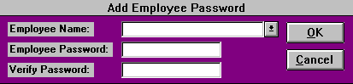

Clear/Delete Employee Password
This form allows the care coordinator or admin to clear an employee’s password or to delete the specified employee’s password account. You should select the desired employee name form the employee name field list box. This list contains all the employees who have employee password account. Once the appropriate employee is chosen, you have the option of clicking the CLEAR PASSWORD or DELETE buttons. The CLEAR PASSWORD button is used to clear out the employee’s old password in case the employee forgot it. The employee can then enter a new password for himself/herself through the “Change Employee Password” accessed through the “Main Menu.” Conversely, clicking the DELETE button will remove the employee’s password account entirely. If an employee is deleted by mistake, you can always create a new password account for the employee through the “Add Employee Password” form.

Exhibit 89: Clear/Delete Employee Password

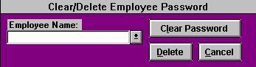

Set Object Permissions
This form allows members of the admins or care coordinators group to set object permissions for each menu object. First, you should select the group he/she wishes to set permissions for from the user group list box. This list contains the following user groups: care coordinators, care supervisors, and care staff. Once the appropriate user group is selected, mark an “X” in the permission boxes of those menu objects you want the selected user group to be able to view. Conversely, unmark the permission boxes of those menu objects you do not want the selected user group to view. Marking and unmarking the permission box can be accomplished by clicking in the box with the your mouse. Click the CLOSE button to return to the “Security Options” form.

Exhibit 90: Object Permissions

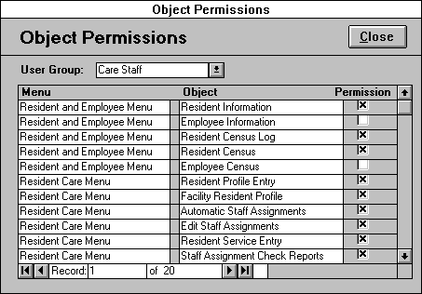

OPTION MENUS

Users can take advantage of the new option menus that are available on most continuous forms (or forms showing a list of records instead of one record at a time). These option menus are located in the upper left portion of the screen and are accessed by clicking once on the menu name. You simply click on the menu command you wish to initiate. The two types of menus and their commands are explained below:

ADVANCED OPTIONS

Sort Ascending
This will sort the records of the current field in ascending order. For example, if you have clicked in the LOA leave date field in the "Resident Census" and accessed the Advanced Options Menu and clicked Sort Ascending, the form will display the records from earliest to most recent.

Sort Descending
This will sort the records of the current field in descending order. For example, if you have clicked in the LOA leave date field in the "Resident Census" and accessed the Advanced Options Menu and clicked Sort Descending, the form will display the records from the most recent to the earliest.

Datasheet View
This will switch the form to datasheet view. Datasheet view displays a form’s information in columns. To select all of a columns and records in a form, click on the small gray box to the left of the first column title. To select a particular column, click on the column title. The user can select multiple columns by clicking the column title and holding the mouse button down while dragging the pointer over the column titles. Release the mouse button when you have selected the desired columns. Another method for selecting multiple columns requires you to hold down the Shift key and click on the column titles of the columns you wish to select. Once a column(s) is selected, the user can move the selected column(s) by clicking on the column title, while holding the mouse button down and dragging the pointer to where he/she wishes to move the column(s). The user also has the option of selecting a record or records by clicking on the record selectors, the small gray boxes to the left of each record. Multiple records can be selected by using either the Shift key or drag and release method. Once the desired data is selected, the user can use the Copy command to copy the data to the Windows Clipboard for use in another application.

Form View
This is the default view of a form. To return to this view from the datasheet one, the user clicks on the Form View command.

Copy
This command will copy the selected text to the Windows clipboard, which can be later retrieved using the Paste command in this or another Windows application. This command is utilized when the user wants to copy information to another place within the program or to export selected information to another application. For example, the user can copy the text in a resident service’s comment field in the “Resident Profile View” form and Paste the copied text into the comment field of a different service. On the other hand, the user can also copy the names and room numbers of the residents from the “Resident Census” form and paste them in an Excel Spreadsheet. To select one record’s filed to copy, click the left mouse button and hold it down as you drag the cursor over the desired text. Release the mouse button when all the desired text has been highlighted and click the Copy command. To copy data for more than one record’s field, first switch to datasheet view by clicking the Datasheet View command from the Advanced Options menu. Then select the data you wish to copy and click the Copy command. (See Datasheet view for data selection tips.)

Paste
This command will take the text previously copied onto the Windows clipboard and paste it into the currently selected location. This command saves the user from having to retype the same information into this program. For example, the user copies the text in a resident service’s comment field in the “Resident Profile View” form and then selects the comment field of the service he/she wishes the text to be entered. Next the user simply clicks the Paste command from the menu and the text is entered in the service’s comment field.

Help
Clicking Help will display the marketing help file, which will open to the topic on which your cursor rests. For example you can press the Help command on the “Resident Census” form, and the help file will pop up with information concerning the “Resident Census.” This command does the same thing as pressing F1.

SORT OPTIONS

Sort Ascending
This will sort the records of the current field in ascending order. For example, if you have clicked in the date field in the "Service Entry Review" and accessed the Advanced Options Menu and clicked Sort Ascending, the form will display the records from earliest to most recent.

Sort Descending
This will sort the records of the current field in descending order. For example, if you have clicked in the date field in the "Service Entry Review" and accessed the Advanced Options Menu and clicked Sort Descending, the form will display the records from the most recent to the earliest.

Copy
This command will copy the selected text to the Windows clipboard, which can be later retrieved using the Paste command in this or another Windows application. This command is utilized when the user wants to copy information to another place within the program or to export selected information to another application. For example, the user can copy the text in a resident service’s comment field in the “Resident Profile View” form and Paste the copied text into the comment field of a different service. To select the data you wish to copy, click the left mouse button and hold it down as you drag the cursor over the desired text. Release the mouse button when all the desired text has been highlighted and click the Copy command.

Paste
This command will take the text previously copied onto the Windows clipboard and paste it into the currently selected location. This command saves the user from having to retype the same information into this program. For example, the user copies the text in a resident service’s comment field in the “Resident Profile View” form and then selects the comment field of the service he/she wishes the text to be entered. Next the user simply clicks the Paste command from the menu and the text is entered in the service’s comment field.

Help
Clicking Help will display the Health Leap help file, which will open on the topic your cursor rests on. For example you can press the Help command on “Service Entry Review”, and the help file will pop up with information concerning the “Service Entry Review.” This command does the same thing as pressing F1.

Table of Exhibits
Exhibit 1: Resident Care Cycle 4
Exhibit 2: Buttons 6
Exhibit 3: Main Menu 7
Exhibit 4: Resident Care Menu 9
Exhibit 5: Resident Profile Entry 12
Exhibit 6: Resident Profile View 13
Exhibit 7: Resident Service Plan 14
Exhibit 8: Facility Resident Profile 16
Exhibit 9: Multiple Service Filter Selection 17
Exhibit 10: Automatic Staff Assignments 18
Exhibit 11: Projected Staff Time 19
Exhibit 12: Assignment Acuity By Unit 20
Exhibit 13: Staff Care Assignments 21
Exhibit 14: Assignment Print Selection 23
Exhibit 15: Assignment Service Count 23
Exhibit 16: Edit Staff Assignments 24
Exhibit 17: Resident Service Entry 26
Exhibit 18: Staff Assignment Check Reports 27
Exhibit 19: Uncompleted Services 28
Exhibit 20: Services Not in Profile 29
Exhibit 21: Employee Service Completion 32
Exhibit 22: Resident Tracking Options 32
Exhibit 23: Resident Tracking Items Entry 34
Exhibit 24: Resident Tracking Items: Report Creation 35
Exhibit 25: Reports Menu 36
Exhibit 26: Actual and Profile Time 37
Exhibit 27: Actual and Profile Service Time 38
Exhibit 28: Actual and Service Time By Unit 39
Exhibit 29: Care Level Graphs 40
Exhibit 30: Resident Time Reports 41
Exhibit 31: Resident Service Time By Week 42
Exhibit 32: Average Resident Service Time 43
Exhibit 33: Resident Service Time Out of Range 44
Exhibit 34: Resident Profile Time Report 45
Exhibit 35: Unit and Care Level Acuity Averages 46
Exhibit 36: Service Entry Review Reports 46
Exhibit 37: Service Entry Review 48
Exhibit 38: Services By Position 49
Exhibit 39: Resident Services Review Reports 50
Exhibit 40: Resident Services Review Reports 50
Exhibit 41: Actual and Profile Service Count 51
Exhibit 42: Resident Services Review 52
Exhibit 43: Resident Service Totals 53
Exhibit 44: Communication Menu 55
Exhibit 45: Resident Progress Notes Entry 56
Exhibit 46: Resident Progress Notes Review 57
Exhibit 47: Progress Notes Count 58
Exhibit 48: Progress Notes Count Report 58
Exhibit 49: Communication Messages Selection 61
Exhibit 50: Communication Messages Report 61
Exhibit 51: Resident and Employee Menu 62
Exhibit 52: Client Contact Information 63
Exhibit 53: Reason For Not Coming Form 64
Exhibit 54: Waiting List Form 66
Exhibit 55: Resident Password 69
Exhibit 56: Resident Information 70
Exhibit 57: Lease Change Options 72
Exhibit 58: Adding Lease Change 73
Exhibit 59: Edit/Delete Lease Change 74
Exhibit 60: Resident Lease Change 75
Exhibit 61: Leave of Absence 76
Exhibit 62: Resident Census Options 77
Exhibit 63: Resident Census 78
Exhibit 64: Resident Discharge Options 79
Exhibit 65: Resident Discharge 80
Exhibit 66: Employee Information 82
Exhibit 67: Employee Census 83
Exhibit 68: Facility Options Menu 84
Exhibit 69: Software Options 87
Exhibit 70: Service List 88
Exhibit 71: Service Replace 89
Exhibit 72: Room Plan 90
Exhibit 73: Services Assignments By Staff Type 91
Exhibit 74: Specific Staff Services Assigned 91
Exhibit 75: Room Assignments By Unit Designation 92
Exhibit 76: Rooms Assigned By Unit Designation 93
Exhibit 77: Archive Service Entry Options 94
Exhibit 78: Communication Messages Review 95
Exhibit 79: Resident Lease Field Options 96
Exhibit 80: Resident Lease Fields 97
Exhibit 81: Resident Face Sheet Lease Field Selection 97
Exhibit 82: Resident Tracking Items 99
Exhibit 83: Security Options 100
Exhibit 84: Create New User 101
Exhibit 85: Delete User 101
Exhibit 86: Clear User Password 101
Exhibit 87: Change User Password 102
Exhibit 88: Add Employee Password 103
Exhibit 89: Clear/Delete Employee Password 103
Exhibit 90: Object Permissions 104

